**chad darby - sb3, spring6, hibernate**

**lesson.5 what is spring-boot**

easier version of spring, still runs spring on the background

it has embedded server, also you can create war files.

**lesson.8 goals of spring**

lightweight development with java POJO (plain old java objects)

dependency injection to achieve loose coupling

minimize boilerplate java code

**lesson.11 what is maven**

project management tool it is used for build management and dependencies

without maven you would have to go to each website of dependencies you need and add them to your jar files.

instead, you say maven what you need and it downloads and runs

maven will handle class/build path for you

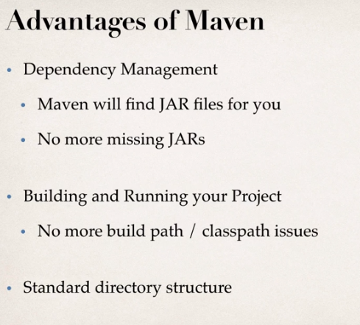

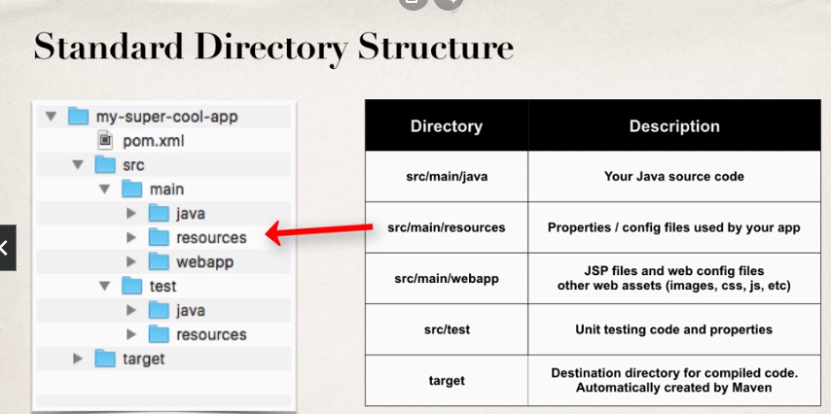

**lesson.12 maven key concepts**

**..pom.xml (project object model file)**

configuration file consists of

project meta-data

dependencies

plug-ins

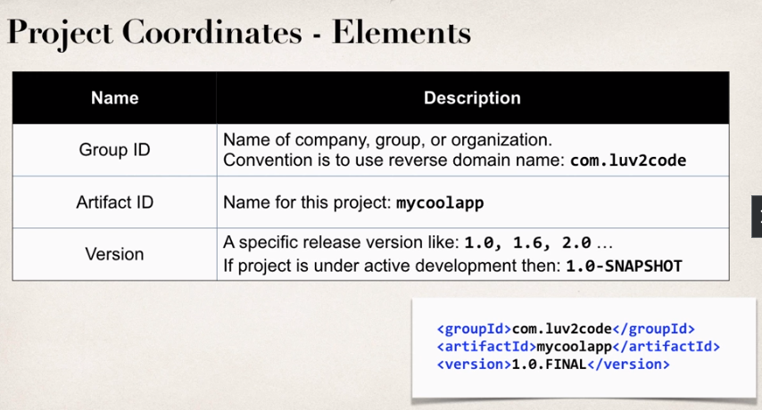

visit search.maven.org to find dependencies

**lesson.15 spring boot files and starters**

static files are loaded from static directory. put static files and spring boot will automatically load

**note:** do not use src/main/webapp directory if your app is a jar

spring boot starters are packs of dependencies for the specified infastracture e.g. spring boot web starter being a collection of spring web,hibernate validator, json etc.

luv2code.com/spring-boot-starters

see the list of dependencies of the starters in the project:

(intellij) view - tool windows - maven - dependencies

**lesson.18 intellij and devtools**

if you use dev-tools in intelliJ:

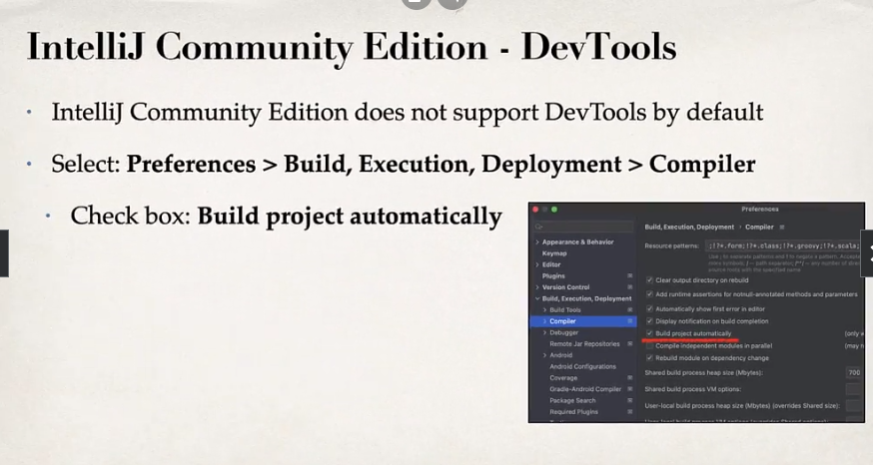

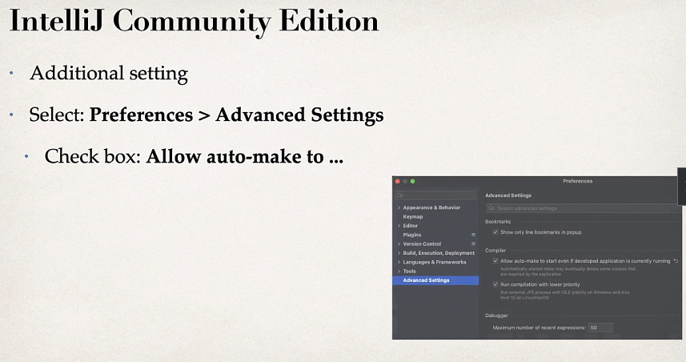

**lesson.20 spring-boot actuator**

devops tool to: expose endpoints for monitoring

add to the dependencies

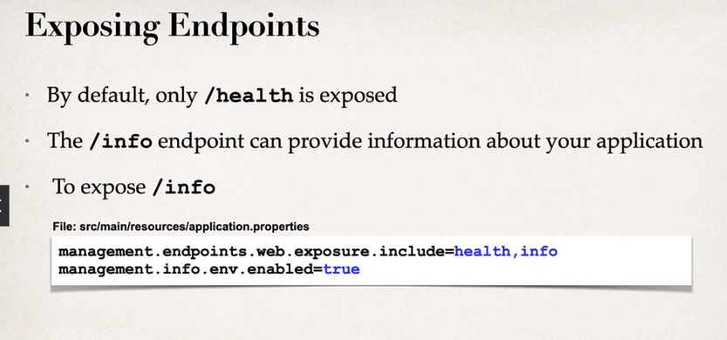

[link]/actuator/health

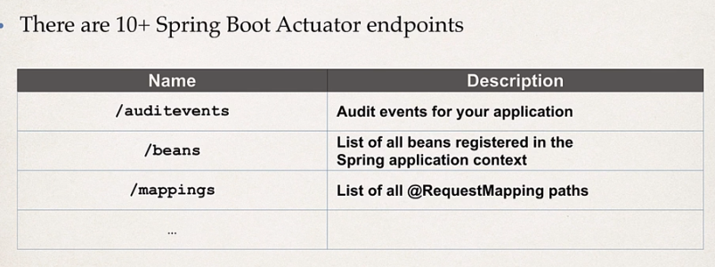

luv2code.com/actuator-endpoints for full list

management.endpoints.web.exposure.include = * (all included)

info.app.name=hello   
info.app.description = testing app  
info.app.version = 0.0.1

to set actuator/info

**lesson.24 security**

spring.security.user.name=admin  
spring.security.user.password=password

to set security creds

**lesson.25 run spring-boot from terminal**

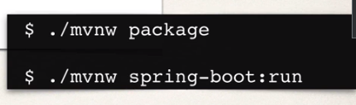

package creates jar file

**lesson.29 some properties commands**

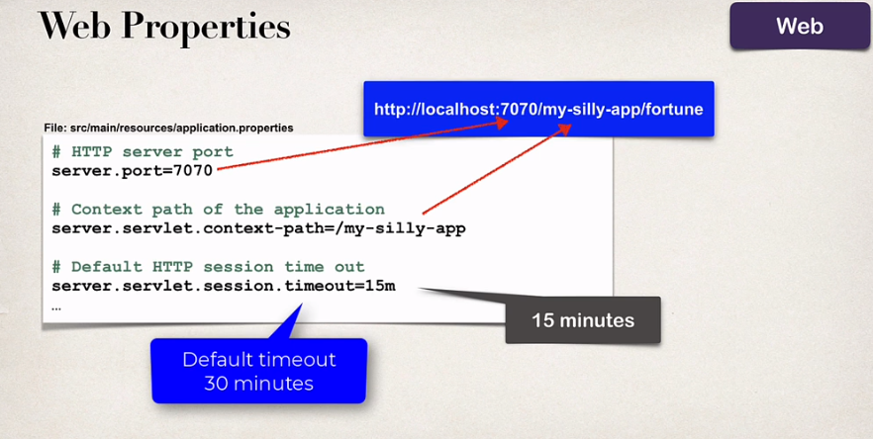

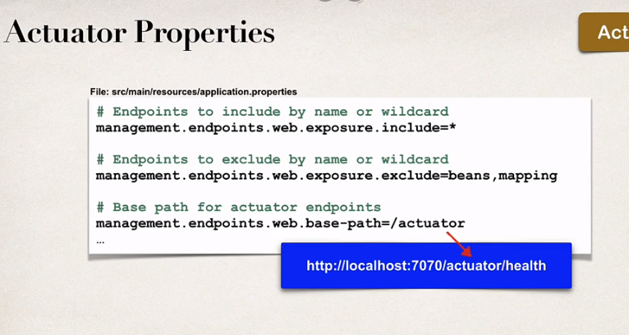

**SECTION.2**

**lesson.31 ioc**

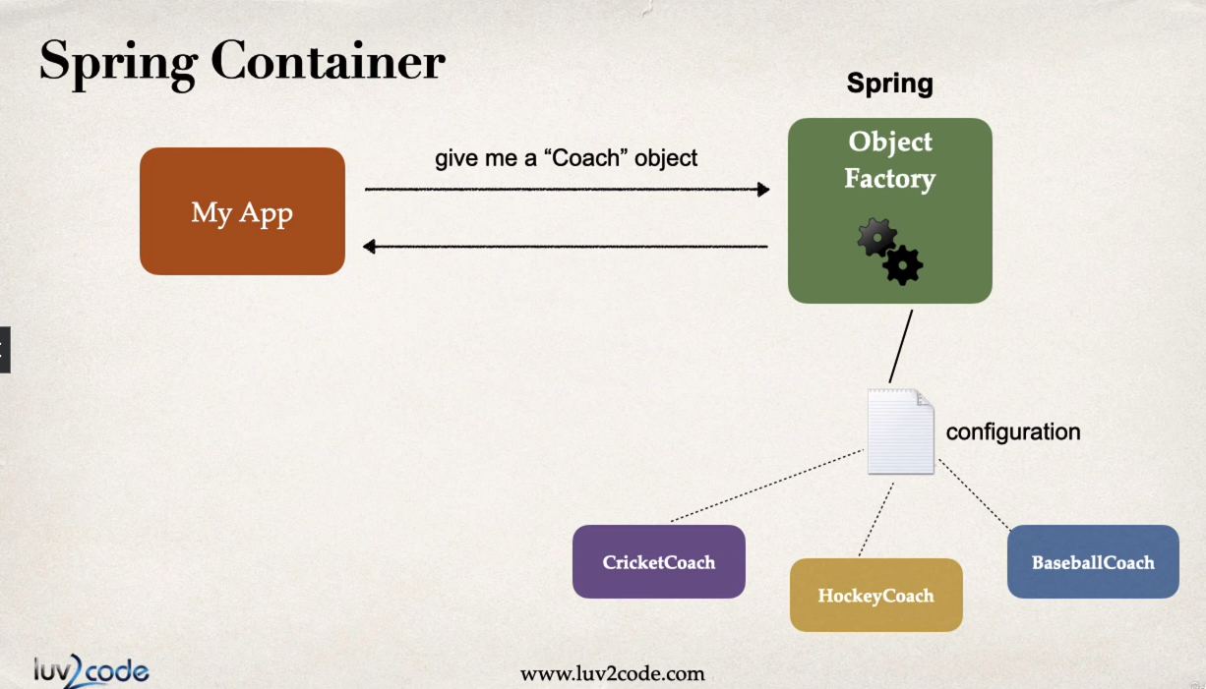

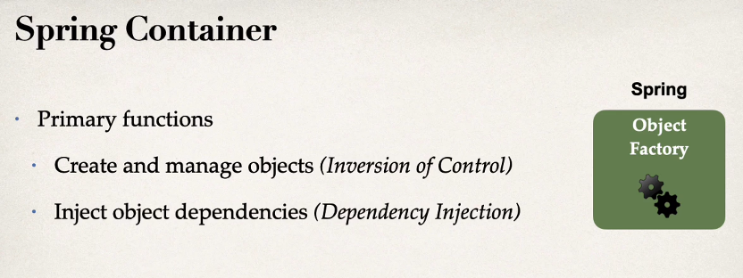

dependency injection example:

you go to car factory request a car

car factory creates a car with its necessary parts(dependencies) and gives you a car

types of injection:

constructor injection : for required injections

setter injection : for optional injections

spring bean: is a regular java class managed by spring

@component makes the bean available for dependency injection

Constructor injection:

public interface Coach {  
  
 public String getWorkout();  
}

coach interface

@Component  
public class CricketCoach implements Coach{  
  
 @Override  
 public String getWorkout() {  
 return "Practice cricket smth";  
 }  
}

Ccoach class

@RestController  
public class DemoController {  
  
 private Coach myCoach;  
  
 @Autowired  
 public DemoController(Coach coach)  
 {  
 myCoach = coach;  
 }  
  
 @GetMapping("/dailyworkout")  
 public String getDailyWorkout()  
 {  
 return "<h1>" + myCoach.getWorkout()+ "</h1>";  
 }  
  
}

rest

**note:** **spring starts component scan with the folder containing application class, then going subfolders, not other folders (parents or same level different folders) by defaults unless:**

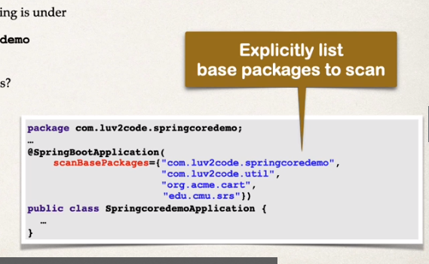

**lesson.41 setter injection**

steps are similar with the constructor injection, but this time setter function is used and annotated

@Autowired  
public void setMyCoach(Coach coach)  
{  
 myCoach = coach;  
}

rest (function name is irrelevant)

**lesson.42 field injection**

no setters or constructors, directly annotating variable

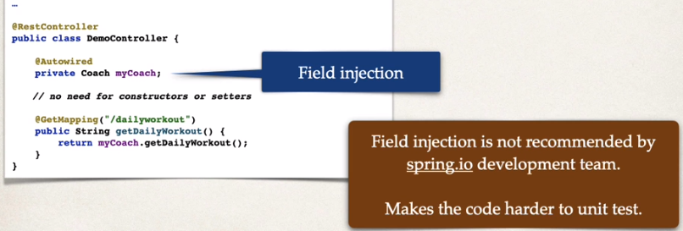

**note: field injection is not recommended because it makes harder to unit test**

**lesson.44 @Qualifier**

on occasions where you inject a bean but there are more than one suitable beans, spring will be confused to which bean to inject

in these scenarios qualifier can be used

@Qualifier("cricketCoach") -> camelcase class name

@Autowired  
public DemoController(@Qualifier("baseballCoach") Coach coach)  
{  
 myCoach = coach;  
}

rest (there are four classes that implement coach interface)

**lesson.47 @Primary**

instead of using qualifier, annotating one class as @Primary can resolve the problem,

**note: if @Primary and @Qualifier is used at the same time, qualifier has higher priority**

**lesson.48 lazy initiation**

by default when application starts spring initializes all beans and make them usable

if you use @Lazy annotation, bean will only be initialized when:

it is needed

it is requested

to apply lazy initialization for entire app, in application.properties: spring.main.lazy-initialization=true

disadvantages:

it will also affect @restcontroller

may not discover config issues until its too late

need to make sure to have enough memory for all beans once created

**lesson.52 bean scopes**

default spring scope is singleton

spring container creates only one instance of the bean

it is cached in memory

all injections will reference the same bean

explicitly specifying scope:

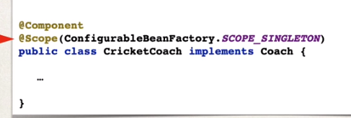

prototype scope:

new object instance for every injection

**lesson.54 bean life cycle**

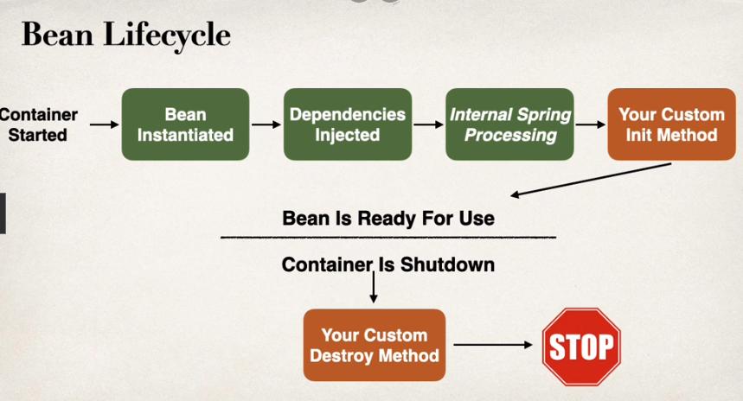

//init method  
@PostConstruct  
public void doStartup()  
{  
 System.*out*.println("this is init method " + getClass().getSimpleName());  
}  
//destroy method  
  
@PreDestroy  
public void doDestroy()  
{  
 System.*out*.println("this is method before destroy " + getClass().getSimpleName());  
}

functions that run after initialization and before destroy

**note: For "prototype" scoped beans, Spring does not call the destroy method. Gasp!** Thus, although initialization lifecycle callback methods are called on all objects regardless of scope, **in the case of prototypes, configured destruction lifecycle callbacks are not called**. The client code must clean up prototype-scoped objects and release expensive resources that the prototype bean(s) are holding.

**lesson.57 java config bean**

in case of not having access to third party class, bean annotation can be used

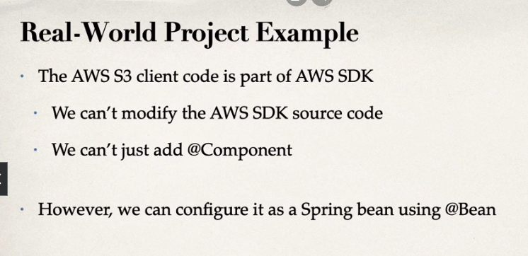

@Autowired  
public DemoController(@Qualifier("swimCoach") Coach coach)  
{  
 System.*out*.println("constructor: " + getClass().getSimpleName());  
 myCoach = coach;  
}

democontroller.java

package com.ucaru.springiocdemo.common;  
  
public class SwimCoach implements Coach{  
  
 public SwimCoach()  
 {  
 System.*out*.println("constructor: " + getClass().getSimpleName());  
 }  
 @Override  
 public String getWorkout() {  
 return "i am swim coach";  
 }  
}

swimcoach.java (no annotation)

package com.ucaru.springiocdemo.config;  
  
import com.ucaru.springiocdemo.common.Coach;  
import com.ucaru.springiocdemo.common.SwimCoach;  
import org.springframework.context.annotation.Bean;  
import org.springframework.context.annotation.Configuration;  
  
@Configuration  
public class SportConfig {  
  
 @Bean  
 public Coach swimCoach()  
 {  
 return new SwimCoach();  
 }  
  
}

@configuration with a @bean method

"swimCoach" in the @Qualifier of the method in democontroller is the same as method name annotated with @bean

@Bean("aqua")  
public Coach swimCoach()  
{  
 return new SwimCoach();  
}

@Autowired  
public DemoController(@Qualifier("aqua") Coach coach)  
{  
 System.*out*.println("constructor: " + getClass().getSimpleName());  
 myCoach = coach;  
}

custom name

**lesson.60 hibernate - jpa**

hibernate is the framework thar allows access to database

jpa is the standard api for object-to-relational-mapping (orm)

requires implementation to be usable

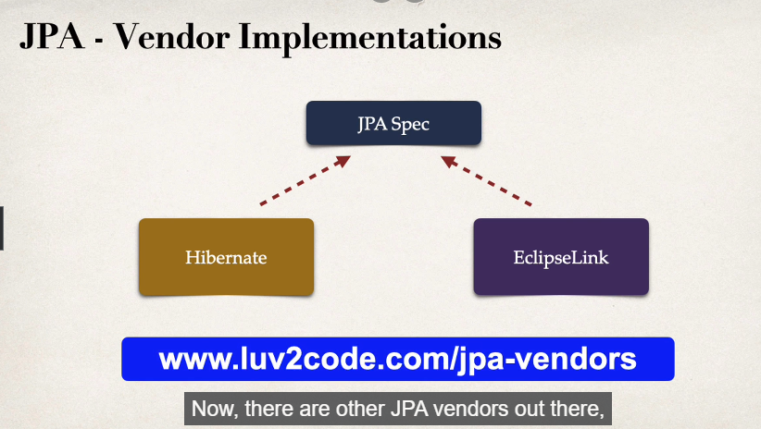

hibernate is an implementation of jpa

**lesson.63 setting up mysql**

download and install mysql and mysql workbench

set up mysql

(watch lesson 64)

**lesson.67 setting up environment**

using start.spring.io, add spring data jpa and mysql dependencies

#turn of banner  
spring.main.banner-mode=off  
  
#reduce logging level  
logging.level.root = warn

@SpringBootApplication  
public class CruddemoApplication {  
  
 public static void main(String[] args) {  
 SpringApplication.*run*(CruddemoApplication.class, args);  
 }  
  
 @Bean  
 CommandLineRunner commandLineRunner(String [] args)  
 {  
 return runner -> {  
 System.*out*.println("hello");  
 };  
 }  
}

create a commandline runner

spring.datasource.url = jdbc:mysql://localhost:3306/student_tracker  
spring.datasource.username = springstudent  
spring.datasource.password = springstudent

set database url and creds

**lesson.68 jpa dev process**

hibernate is the default jpa implementation in spring-boot

entity class - java class that is mapped to a database table

entity class:

must be annotated with @entity

must have public or protected no argument constructor

(class can have other constructors)

java annotations:

map class to a db table

map fields to db columns

step1 - map class to a db table

@Entity

@Table(name="student")

Class Student{

step2 - map fields

@Id

@Column(name="id")

private int id

**note: if column name is not specified, column name is the same as java field (not recommended), same applies to the @table**

@GeneratedValue(strategy = GenerationType.IDENTITY) - not null auto increment

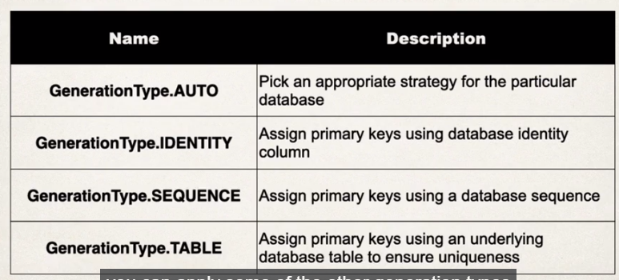

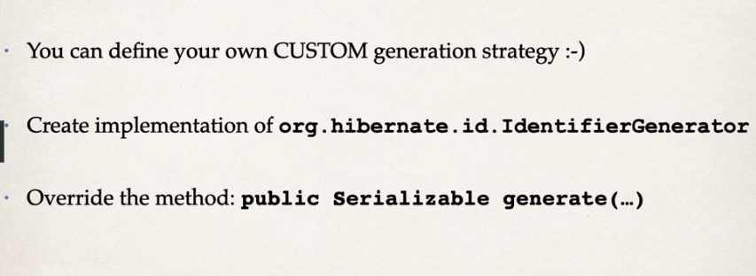

**lesson.70 save an object with jpa**

dao(data access object)

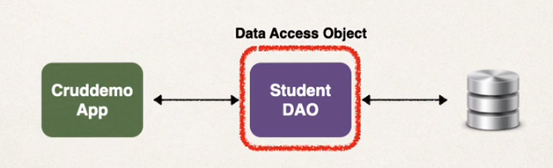

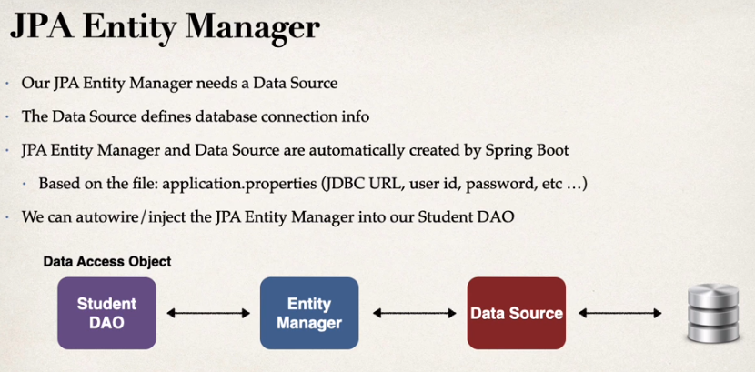

package com.ucaru.cruddemo.dao;  
  
import com.ucaru.cruddemo.entity.Student;  
public interface StudentDAO {  
  
 public void save(Student student);  
}

studentdao.java

import org.springframework.transaction.annotation.Transactional;  
  
@Repository  
public class StudentDAOImpl implements StudentDAO{  
  
 private EntityManager entityManager;  
  
 @Autowired  
 public StudentDAOImpl(EntityManager manager)  
 {  
 this.entityManager = manager;  
 System.*out*.println("i am studentdaoimpl");  
 }  
  
 @Override  
 @Transactional  
 public void save(Student student) {  
 entityManager.persist(student);  
 }  
}

studentdaoimpl.java

@SpringBootApplication  
public class CruddemoApplication {  
  
 public static void main(String[] args) {  
 SpringApplication.*run*(CruddemoApplication.class, args);  
 }  
  
 @Bean  
 CommandLineRunner commandLineRunner(StudentDAO studentDAO)  
 {  
 return runner -> {  
 System.*out*.println("hello");  
 createStudent(studentDAO);  
 };  
 }  
  
 public void createStudent(StudentDAO studentDAO)  
 {  
 // create the student  
 Student student = new Student("jacob","jason","jj@ucaru.com");  
 System.*out*.println("new student");  
 //save student  
 studentDAO.save(student);  
 //display id of the student  
 System.*out*.println("save student. id: " + student.getId());  
 }  
}

application.java

(notice studentdao is not variable, rather a parameter of function, and still it works)

@Transactional is used because function updates db table

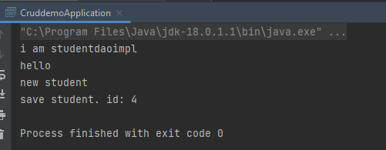

(studentimpl is injected)

sql commands:

ALTER TABLE student_tracker.student AUTO_INCREMENT=0

change index of auto_increment

TRUNCATE student_tracker.student

reset everything

**lesson.75 reading object**

in order to create findById method:

update interface

public interface StudentDAO {  
  
 public void save(Student student);  
  
 public Student findById(Integer id);  
}

studentDao.java

implement in the class

@Override  
public Student findById(Integer id) {  
 return entityManager.find(Student.class, id);  
}

studentDaoImpl.java

(parameter is Integer although id is int in student class, function still works when parameter is int not Integer)

(also notice this function does not need @Transactional because it does not update anything)

public void findStudent(StudentDAO studentDAO)  
{  
 // create the student  
 Student student = new Student("jacob","jason","jj@ucaru.com");  
 System.*out*.println("new student");  
 //save student  
 studentDAO.save(student);  
 //display id of the student  
 System.*out*.println("save student. id: " + student.getId());  
 //find student  
 Student foundStudent = studentDAO.findById(student.getId());  
 //display found student  
 System.*out*.println("found student, id: " + foundStudent.getId());  
}

in use

**lesson.77 querying objects**

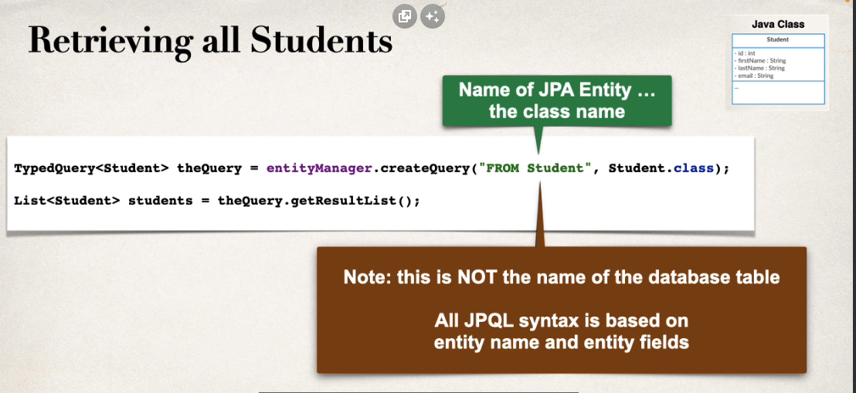

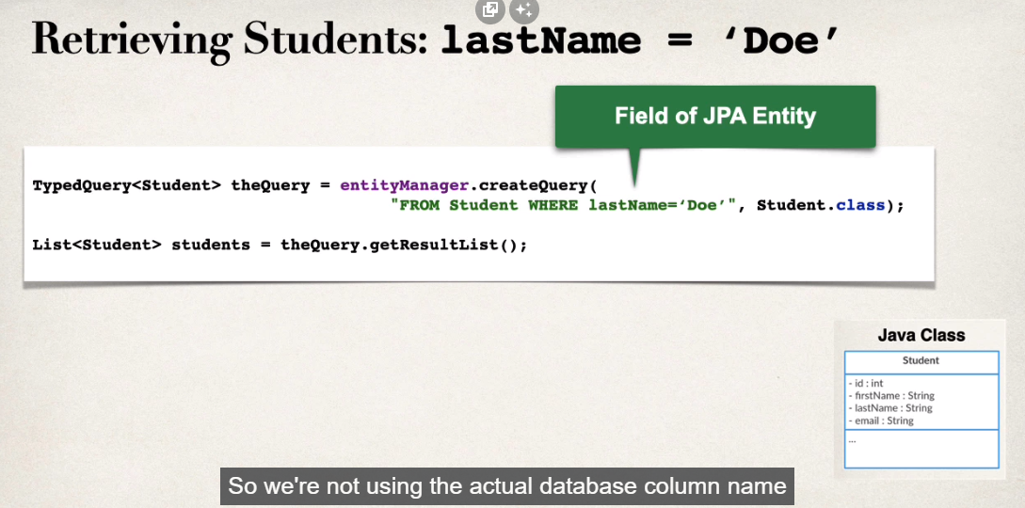

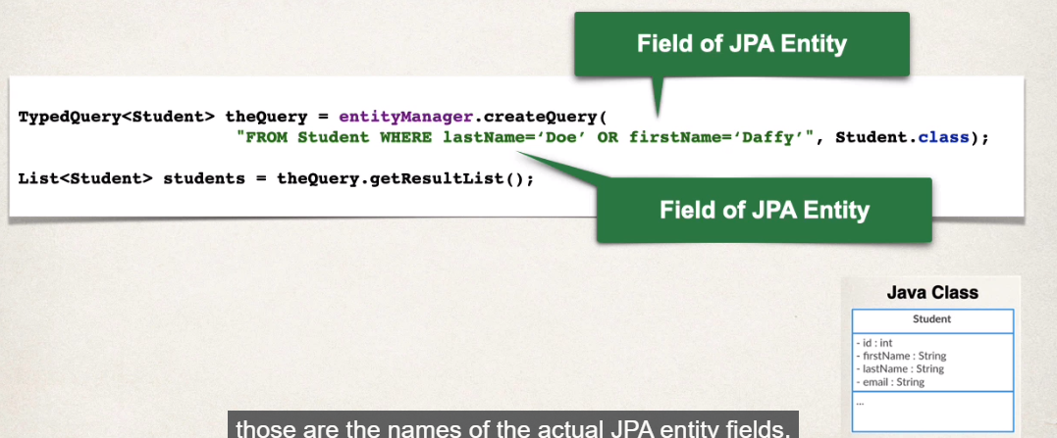

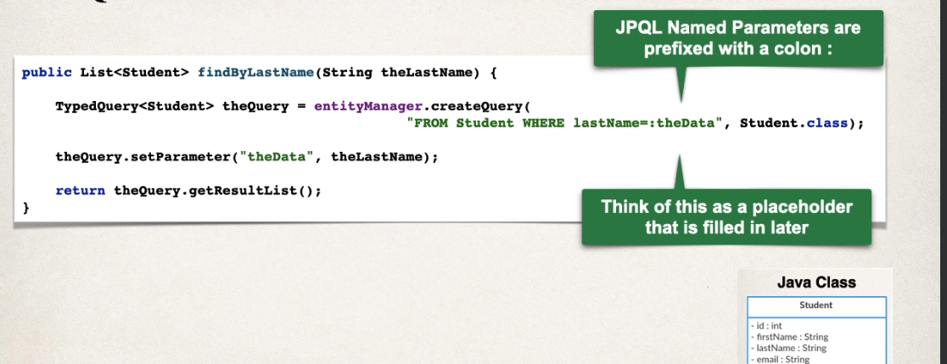

@Override  
public List<Student> findByLastName(String lastName) {  
 //create query  
 TypedQuery<Student> query = entityManager.createQuery("FROM Student WHERE lastName= :theData",Student.class);  
 //set parameter  
 query.setParameter("theData",lastName);  
 //return result  
 return query.getResultList();  
}

daoimpl.java

@Override  
public List<Student> findAll() {  
 TypedQuery<Student> query = entityManager.createQuery("FROM Student", Student.class);  
  
 return query.getResultList();  
}

no transactional since we don't change anything

**lesson.80 updating objects**

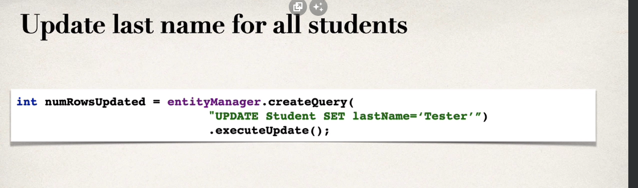

can be done using query

@Override  
@Transactional  
public void update(Student student) {  
 entityManager.merge(student);  
}

impl.java

private void updateStudent(StudentDAO studentDAO) {  
 //retrieve student  
 int studentId = 4;  
 System.*out*.println("retrieving student id: " + studentId);  
 Student myStudent = studentDAO.findById(studentId);  
 //change first name  
 System.*out*.println("update student");  
 myStudent.setFirstName("jacob");  
 studentDAO.update(myStudent);  
 //display updated student  
 System.*out*.println("updated student: " + myStudent);  
}

main

**lesson.81 delete an object**

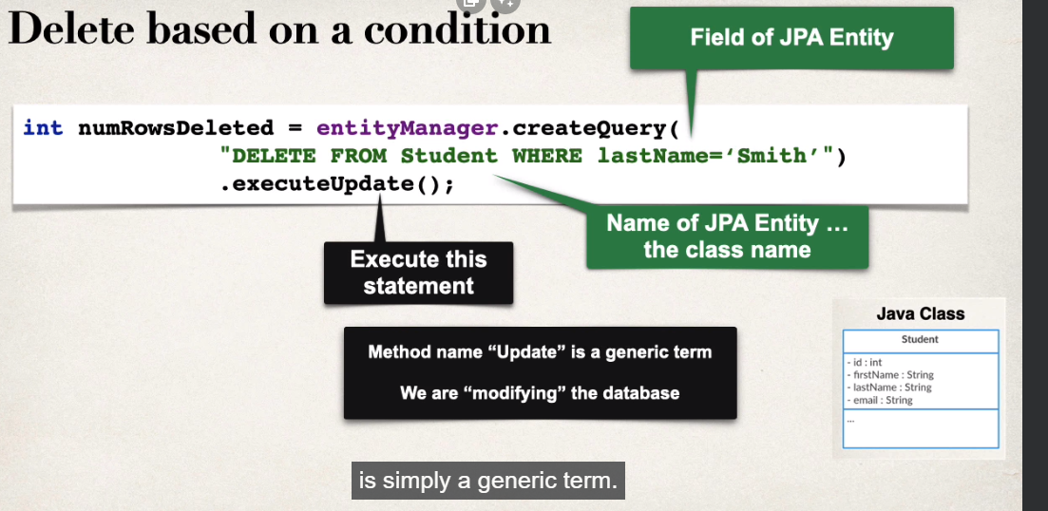

@Override  
@Transactional  
public void delete(Integer id) {  
 //get the student  
 Student student = findById(id);  
 //delete student  
 entityManager.remove(student);  
}

daoimpl.java

private void deleteStudent(StudentDAO studentDAO) {  
 int studentId = 5;  
 System.*out*.println("deleting student id: " + studentId);  
 studentDAO.delete(studentId);  
}

main

@Override  
@Transactional  
public int deleteAll() {  
 int numRowsDeleted = entityManager.createQuery("DELETE FROM Student").executeUpdate();  
 return numRowsDeleted;  
}

daoimpl.java

private void deleteAll(StudentDAO studentDAO) {  
 System.*out*.println("deleting all data");  
 int deletedStudent;  
 deletedStudent =studentDAO.deleteAll();  
 System.*out*.println("deleted: "+deletedStudent + " rows");  
}

main

**lesson.85 create db tables from java code**

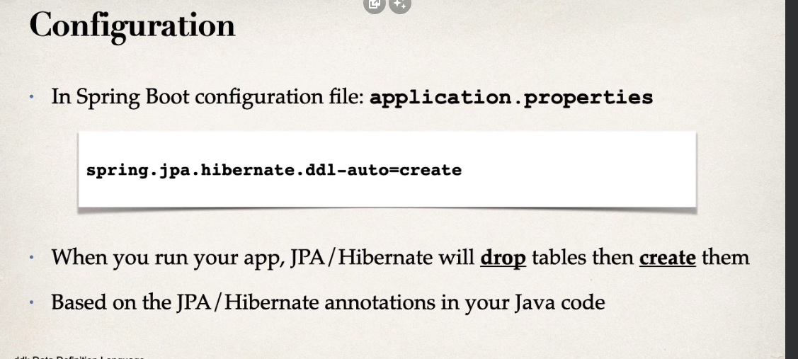

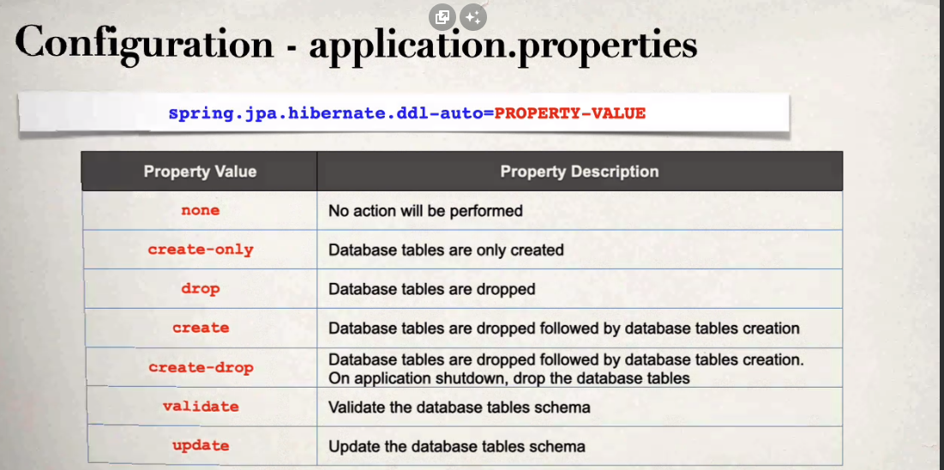

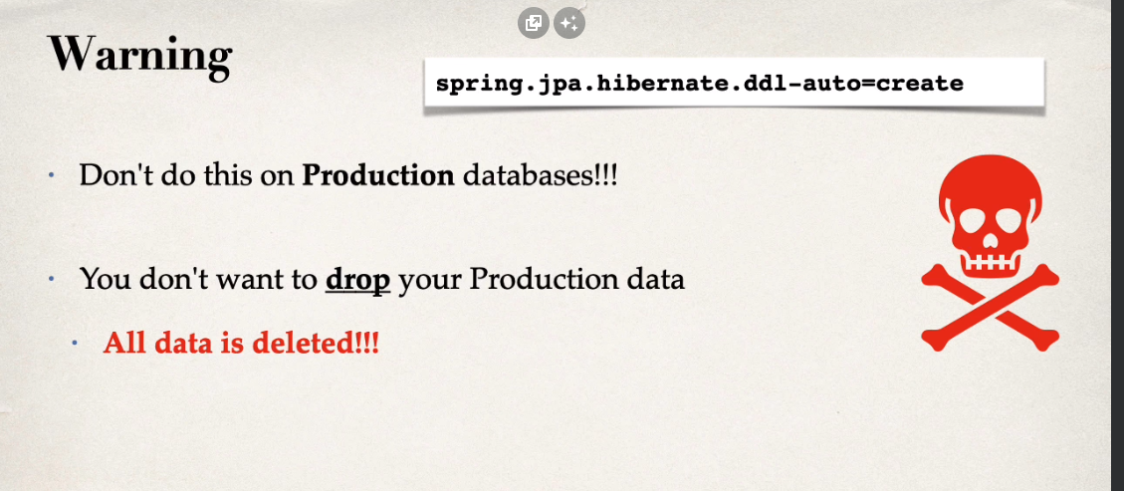

#add logging to show sql statements  
logging.level.org.hibernate.SQL = debug  
logging.level.org.hibernate.orm.jdbc.bind=trace

logging.level.org.springframework.jdbc.core = TRACE

spring.jpa.hibernate.ddl-auto=create

**lesson.88 rest services**

check spring reference manual

REST: REpresentational State Transfer

lightweight approach for communicating between apps

**lesson.90 json basics**

Javascript Object Notation

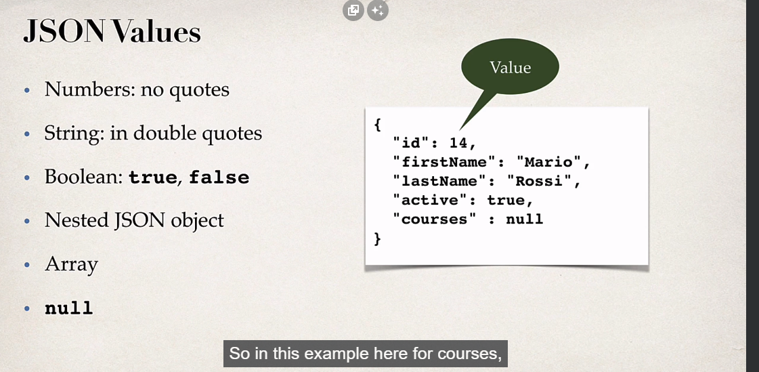

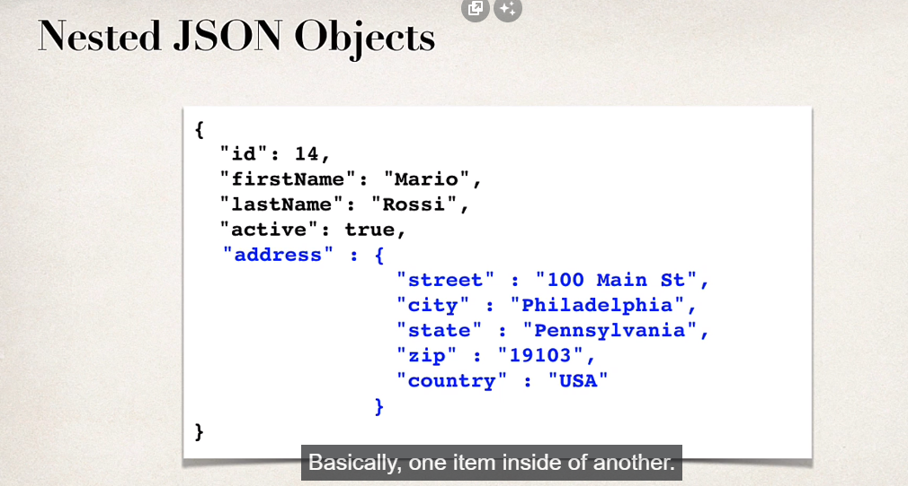

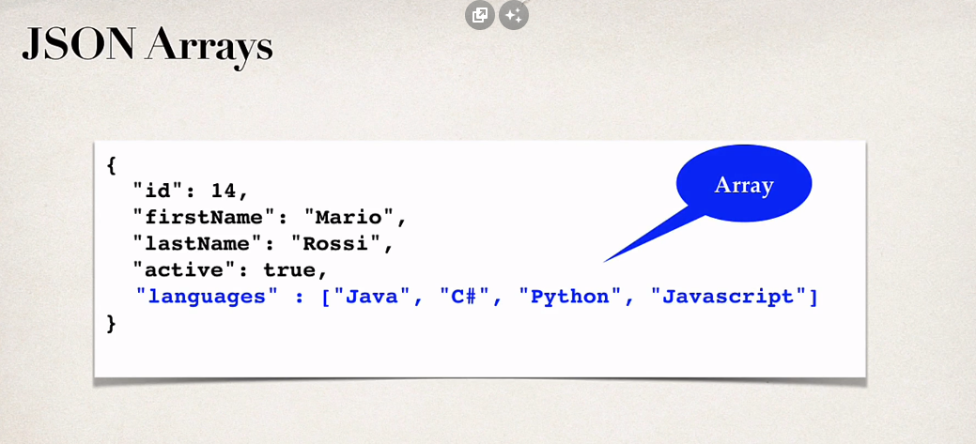

**lesson.91 rest http basics**

POST -> CREATE NEW ENTITY

GET -> READ A LIST OF ENTITIES OR SINGLE ENTITY

PUT -> UPDATE AN EXISTING ENTITY

DELETE -> DELETE AN EXISTING ENTITY

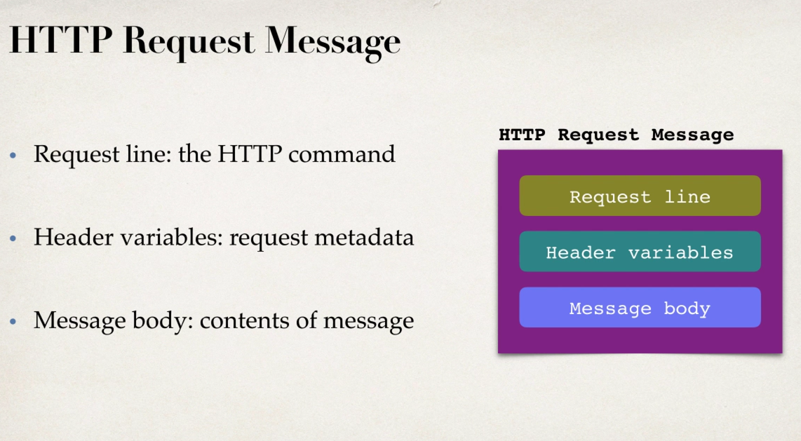

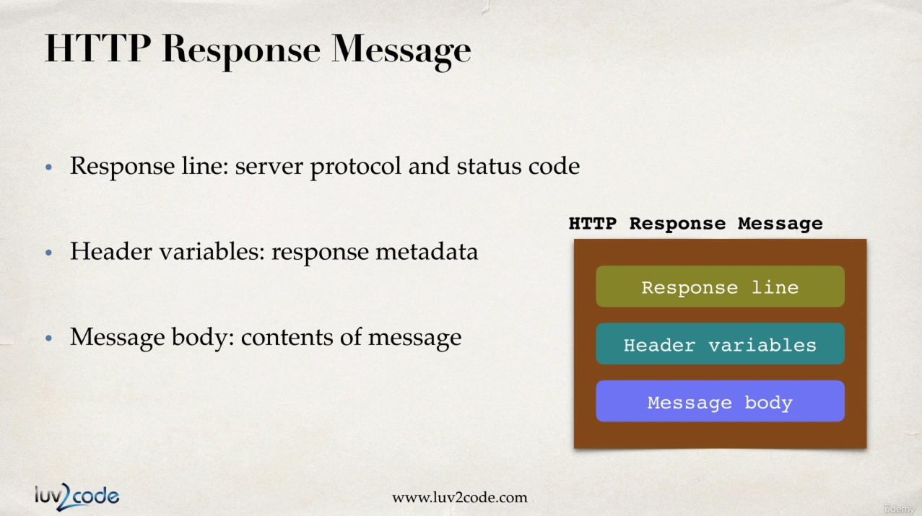

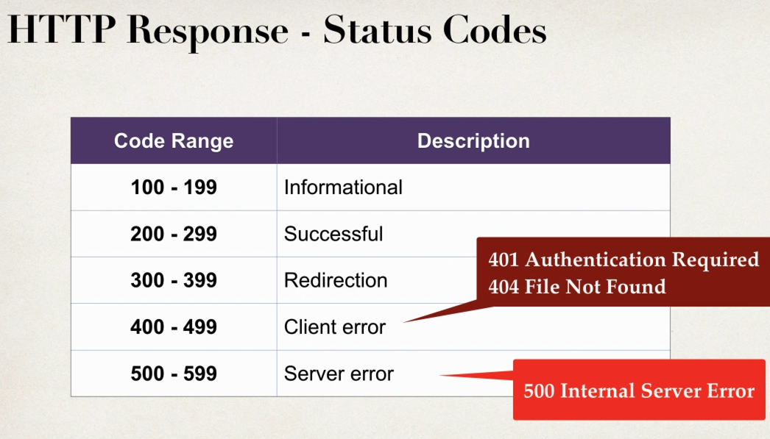

MIME Content types:

syntax: type/sub-type e.g. text/html, text/plain

application/json, application/xml

**lesson.96 json data binding**

data binding is the process of converting json data to java pojo (plain old java object aka class)

that operation is done by Jackson project (comes with spring web)

from json to pojo jackson calls setter methods. it won't have access to private fields, will only call the setter methods

from pojo to json jackson will call getter methods

json data being passed to RESTcontroller is converted to pojo

java object being returned from RESTcontroller is converted to json

@GetMapping("/students")  
public List<Student> getStudents()  
{  
 List<Student> students = new ArrayList<>();  
  
 students.add(new Student("ahmet","muhsin"));  
 students.add(new Student("ahmet","mohsin"));  
 students.add(new Student("ahmad","mugsin"));  
 students.add(new Student("ahmedi","muhsin"));  
  
 return students;  
}

arraylist is converted to json by jackson (hashmap isn't)

**lesson.100 path variables**

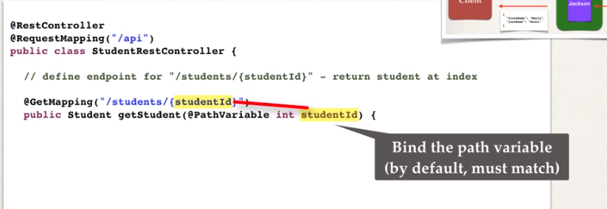

@RequestMapping("/api")  
public class StudentRestController {  
  
 private List<Student> students;  
  
 @PostConstruct  
 public void loadData()  
 {  
 students = new ArrayList<>();  
 students.add(new Student("ahmet","muhsin"));  
 students.add(new Student("ahmet","mohsin"));  
 students.add(new Student("ahmad","mugsin"));  
 students.add(new Student("ahmedi","muhsin"));  
 }  
 @GetMapping("/students/{studentID}")  
 public Student getStudent(@PathVariable int studentID)  
 {  
 return students.get(studentID);  
 }

**lesson.103 & 104 exception handling**

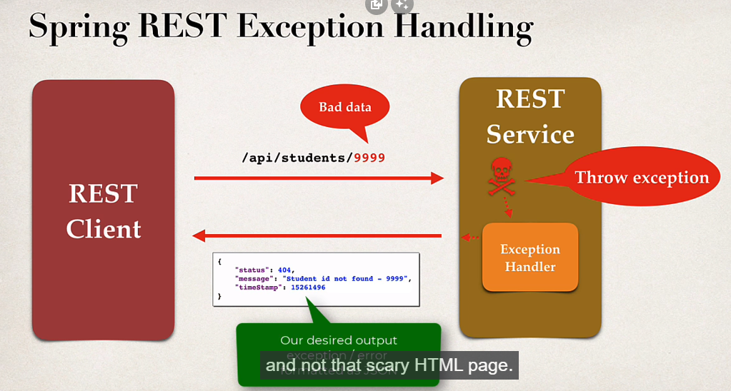

@GetMapping("/students/{studentID}")  
public Student getStudent(@PathVariable int studentID)  
{  
 //check student id  
 if(studentID >= students.size() || studentID < 0)  
 {  
 throw new StudentNotFoundException("student id not found: "+ studentID);  
 }  
 return students.get(studentID);  
  
}

restController

public class StudentNotFoundException extends RuntimeException{  
  
 public StudentNotFoundException(String message) {  
 super(message);  
 }  
  
 public StudentNotFoundException(String message, Throwable cause) {  
 super(message, cause);  
 }  
  
 public StudentNotFoundException(Throwable cause) {  
 super(cause);  
 }  
}

(in rest package)

public class StudentErrorResponse {  
  
 private int status;  
 private String message;  
 private long timeStamp;  
  
 public StudentErrorResponse()  
 {  
  
 }

(in rest package)

@ExceptionHandler  
public ResponseEntity<StudentErrorResponse> handleException(StudentNotFoundException exc)  
{  
 // create a response  
 StudentErrorResponse errorResponse = new StudentErrorResponse();  
 errorResponse.setStatus(HttpStatus.*NOT_FOUND*.value());  
 errorResponse.setMessage(exc.getMessage());  
 errorResponse.setTimeStamp(System.*currentTimeMillis*());  
 //return responseEntity  
 return new ResponseEntity<>(errorResponse,HttpStatus.*NOT_FOUND*);  
}  
  
//add a generic exception handler  
@ExceptionHandler  
ResponseEntity<StudentErrorResponse> handleException(Exception exc)  
{  
 // create a response  
 StudentErrorResponse errorResponse = new StudentErrorResponse();  
 errorResponse.setStatus(HttpStatus.*BAD_REQUEST*.value());  
 errorResponse.setMessage(exc.getMessage());  
 errorResponse.setTimeStamp(System.*currentTimeMillis*());  
 //return responseEntity  
 return new ResponseEntity<>(errorResponse,HttpStatus.*BAD_REQUEST*);  
  
}

restcontroller

if student id is out of bounds, throw new exception ( StudentNotFoundException extends RuntimeException)

create an exceptionhandler function annotated @ExceptionHandler

ResponseEntity<StudentErrorResponse> handleError(StudentNot... exc)

inside function, create a new studenterrorresponse and set var.

return new ResponseEntity<>(error, httpStatus);

**lesson.111 global exception handling**

@ControllerAdvice is similar to a filter

pre-process request to controllers

post-process responses to handle exceptions

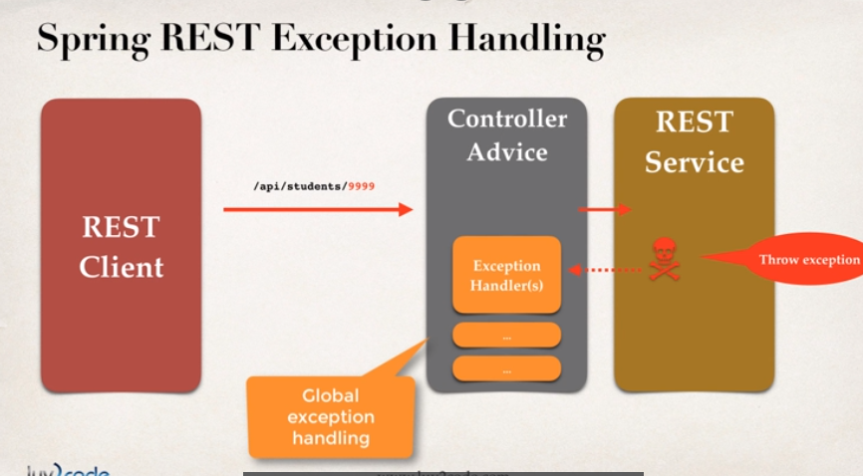

**.note: best practice for handling exceptions**

**.application:**

1. create handler class under rest package

2. cut & paste handler functions

@ControllerAdvice  
public class StudentRestExceptionHandler {  
  
 //add exception handling code  
 @ExceptionHandler  
 public ResponseEntity<StudentErrorResponse> handleException(StudentNotFoundException exc)  
 {  
 // create a response  
 StudentErrorResponse errorResponse = new StudentErrorResponse();  
 errorResponse.setStatus(HttpStatus.*NOT_FOUND*.value());  
 errorResponse.setMessage(exc.getMessage());  
 errorResponse.setTimeStamp(System.*currentTimeMillis*());  
 //return responseEntity  
 return new ResponseEntity<>(errorResponse,HttpStatus.*NOT_FOUND*);  
 }  
  
 //add a generic exception handler  
 @ExceptionHandler  
 ResponseEntity<StudentErrorResponse> handleException(Exception exc)  
 {  
 // create a response  
 StudentErrorResponse errorResponse = new StudentErrorResponse();  
 errorResponse.setStatus(HttpStatus.*BAD_REQUEST*.value());  
 errorResponse.setMessage(exc.getMessage());  
 errorResponse.setTimeStamp(System.*currentTimeMillis*());  
 //return responseEntity  
 return new ResponseEntity<>(errorResponse,HttpStatus.*BAD_REQUEST*);  
  
 }  
  
}

**lesson.113 springboot api design - best practices**

1.design api based on requirements

2. to identify main resource/entity, look for the most prominent noun

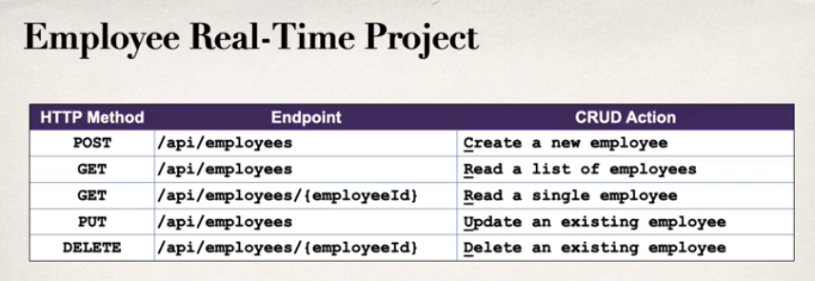

**.bad practices:**

dont include actions in the endpoint (e.g. api/updateEmployees)

use http methods

**lesson.116 create table**

open springstudent server and run downloaded script

**lesson.122 @Service service layer**

look up: facade design pattern:

facade design pattern creates an 'interface' between client and complex background structure, (in our case it is between rest and dao)

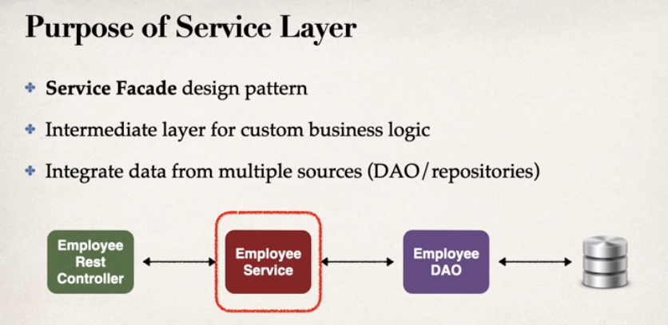

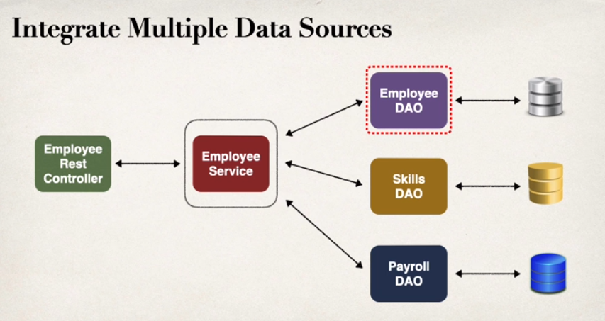

@Service is for service implementation

1. define service interface

2. define service implementation

1.inject employeeDAO

package com.ep4.cruddemo.service;  
  
import com.ep4.cruddemo.entity.Employee;  
  
import java.util.List;  
  
public interface EmployeeService {  
  
 List<Employee> findAll();  
}

service packet

import java.util.List;  
  
@Service  
public class EmployeeServiceImpl implements EmployeeService{  
  
 EmployeeDAO employeeDAO;  
  
 @Autowired  
 public EmployeeServiceImpl(EmployeeDAO employeeDAO) {  
 this.employeeDAO = employeeDAO;  
 }  
  
 @Override  
 public List<Employee> findAll() {  
 return employeeDAO.findAll();  
 }  
  
}

implementation of the interface

**lesson.124 DAO implementation**

**.best practice for service-dao implementation**

transactional annotation should be on the service layer because actually service layer is responsible for setting transaction boundaries

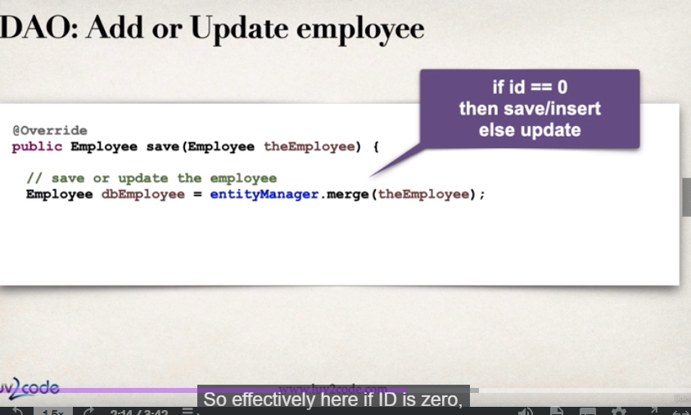

**lesson.125 CRUD**

public interface EmployeeDAO {  
  
 List<Employee> findAll();  
  
 Employee findById(int id);  
  
 Employee save(Employee theEmployee);  
  
 void deleteById(int id);  
}

add new methods to dao interface

@Override  
public Employee findById(int id) {  
 return entityManager.find(Employee.class, id);  
}  
  
//if id is zero or empty?? it will add to db (persist)  
@Override  
public Employee save(Employee theEmployee) {  
 Employee dbEmployee = entityManager.merge(theEmployee);  
 return dbEmployee;  
}  
  
@Override  
public void deleteById(int id) {  
 Employee dbEmployee = entityManager.find(Employee.class, id);  
 entityManager.remove(dbEmployee);  
}

implement methods to %DAOImpl.java

(@transactional is not here but in service layer)

entityManager.merge() method adds a new entry to database if id of the object is zero

public interface EmployeeService {  
  
 List<Employee> findAll();  
  
 Employee findById(int id);  
  
 Employee save(Employee theEmployee);  
  
 void deleteById(int id);  
}

service interface

@Override  
public Employee findById(int id) {  
 return employeeDAO.findById(id);  
}  
  
@Transactional  
@Override  
public Employee save(Employee theEmployee) {  
 return employeeDAO.save(theEmployee);  
}  
  
@Transactional  
@Override  
public void deleteById(int id) {  
 employeeDAO.deleteById(id);  
}

service implementation, notice @transactional

//expose /employees/{id}  
@GetMapping("/employees/{employeeID}")  
public Employee getEmployee(@PathVariable int employeeID)  
{  
 Employee theEmployee = employeeService.findById(employeeID);  
 if(theEmployee == null)  
 {  
 throw new RuntimeException("not found: "+ employeeID);  
 }  
 return theEmployee;  
}  
  
@PostMapping("/employees")  
public Employee addEmployee(@RequestBody Employee theEmployee)  
{  
 //override theEmployee id with 0 to force-save  
 theEmployee.setId(0);  
  
 Employee dbEmployee = employeeService.save(theEmployee);  
 return dbEmployee;  
}

restcontroller

to test postmapping, use postman with POST header and JSON body

**lesson.131 spring data jpa**

instead of manually coding dao, spring jpaInterface can be used for basic methods like findAll, findByName, save, delete etc.

requires no implementation

can be extended custom queries with

jpql

Query DSL

low-level coding

@Override  
public Employee findById(int id) {  
 //java 8 new approach  
 Optional<Employee> result = employeeRepository.findById(id);  
 Employee theEmployee = null;  
 if(result.isPresent())  
 {  
 theEmployee = result.get();  
 }  
 else  
 {  
 throw new RuntimeException("employee not found: " + id);  
 }  
 return theEmployee;  
}

findById is not declared in the jpa interface. right click findByid function in service impl, refactor, introduce variable

**lesson.134 spring boot rest**

spring data rest exposes basic endpoints without implementation

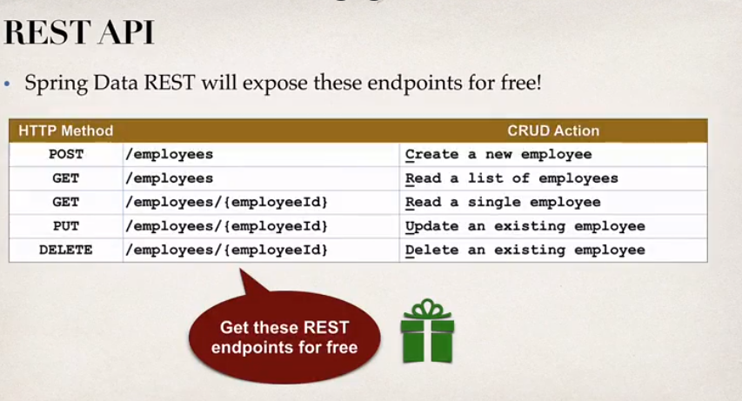

works with jparepository

will use simple pluralized form (Employee -> employees)

how to implement: add dependency to maven

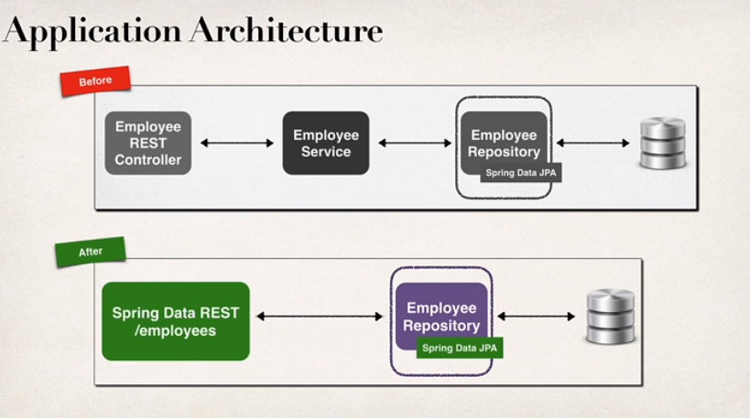

spring data rest endpoints are HATEOAS compliant

HATEOAS: hypermedia as the engine of application state

hypermedia-driven sites provide information to access REST interfaces (think of it as metadata for rest data)

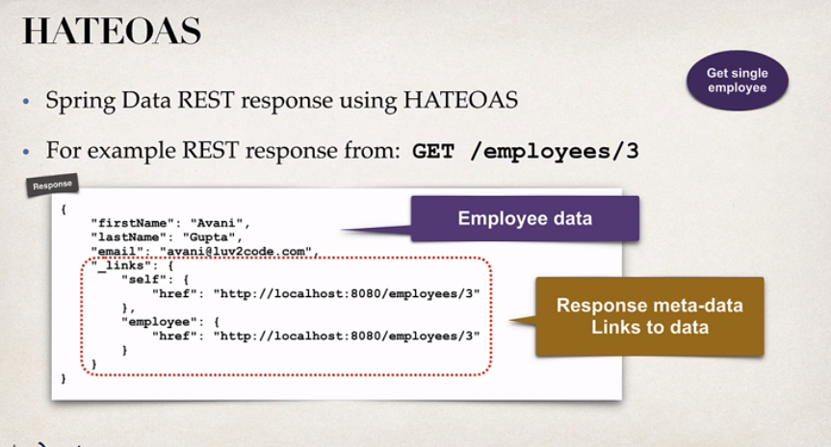

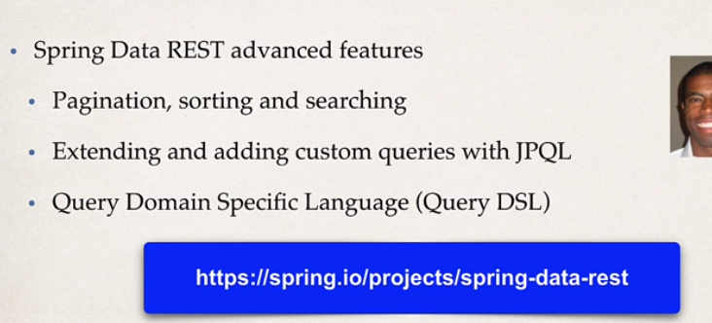

<dependency>  
 <groupId>org.springframework.boot</groupId>  
 <artifactId>spring-boot-starter-data-rest</artifactId>  
</dependency>

add dependency

delete service and rest packages

**lesson.137 spring boot rest - configs and sorting**

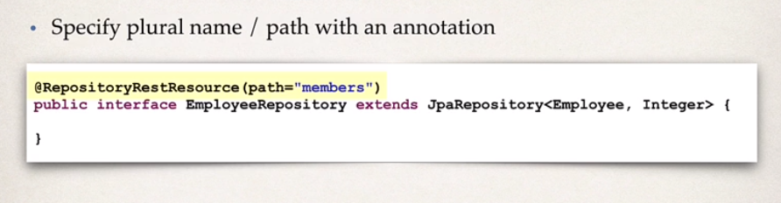

select your path name

spring data rest returns data by page, default page size is 20

localhost:8080/employees?page=0 <- access to first page

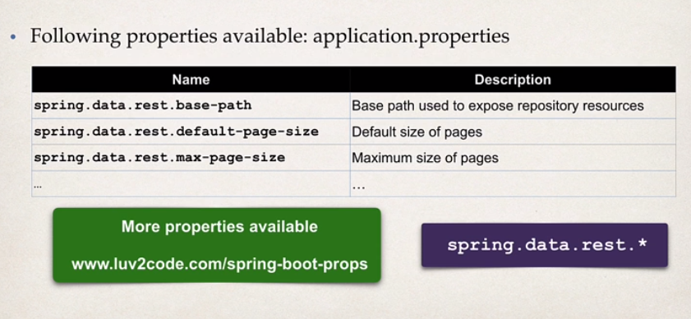

sorting:

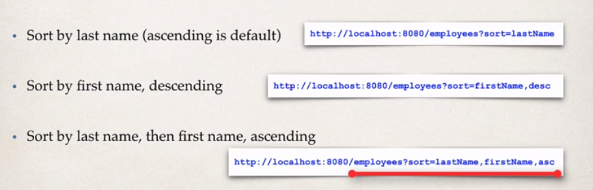

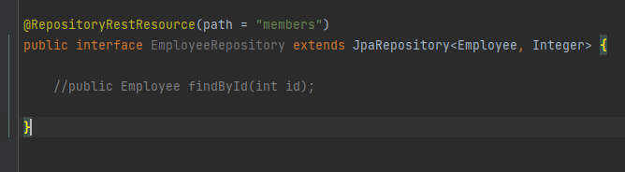

**ep.5 security**

**lesson.139 spring security**

spring securtiy uses servlet filters

they are used to pre-process / post-process web requests

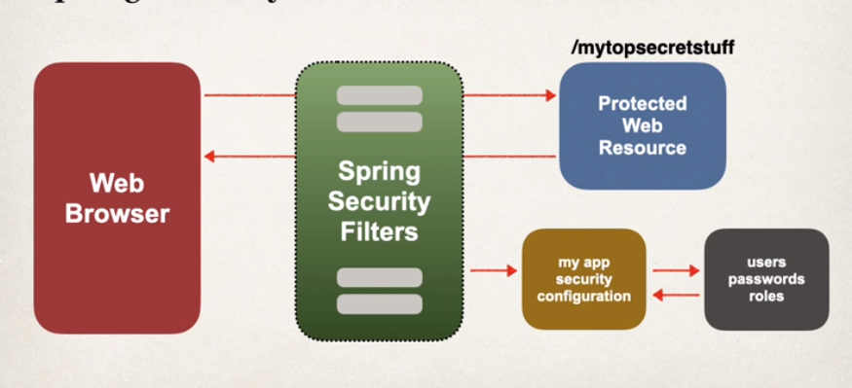

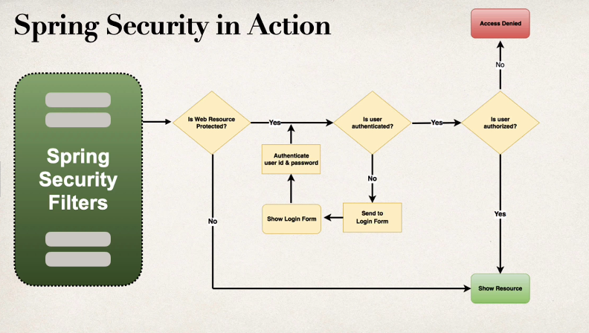

security concepts

authentication

check user id and password with credentials stored in app/db

authorization

check to see if user has an authorized role

1.declarative security

define security constraints in configuration @Configuration

2.programmatic security

spring security provides an api for custom application coding

provides greater customization

set spring security username and password:

application.properties:

spring.security.user.name =

spring.security.user.password =

**lesson.142 security basic configuration**

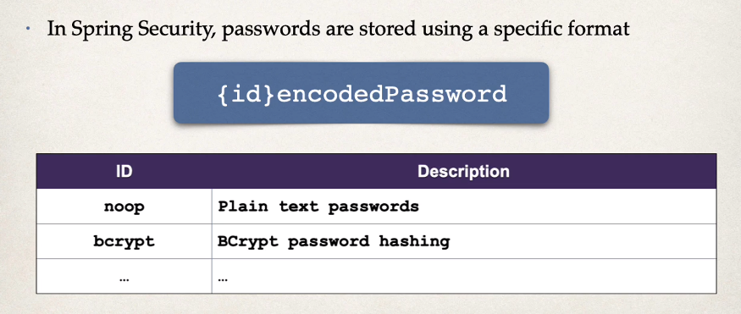

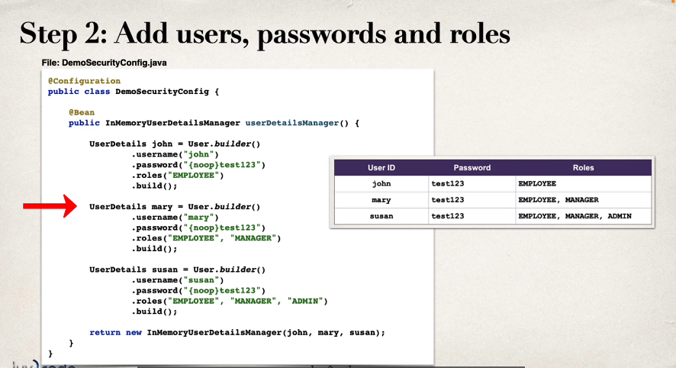

@Configuration  
public class DemoSecurityConfig {  
  
 @Bean  
 public InMemoryUserDetailsManager userDetailsManager()  
 {  
 UserDetails john = User.*builder*()  
 .username("john")  
 .password("{noop}password")  
 .roles("EMPLOYEE")  
 .build();  
 UserDetails mary = User.*builder*()  
 .username("mary")  
 .password("{noop}password")  
 .roles("EMPLOYEE", "MANAGER")  
 .build();  
 UserDetails susan = User.*builder*()  
 .username("susan")  
 .password("{noop}password")  
 .roles("EMPLOYEE", "MANAGER", "ADMIN")  
 .build();  
  
 return new InMemoryUserDetailsManager(john, mary, susan);  
 }  
  
}

package security

**lesson.144 restrict access based on role**

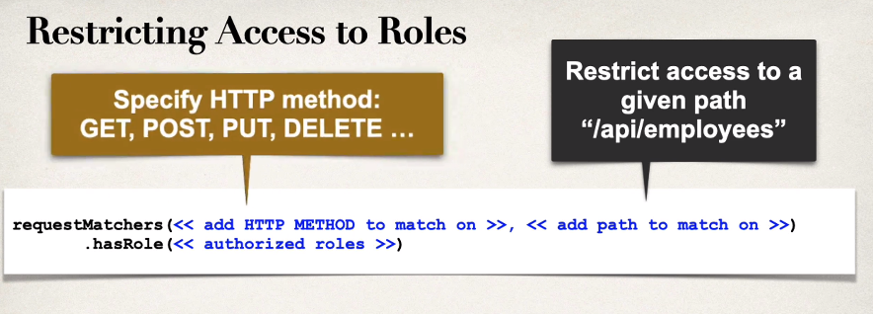

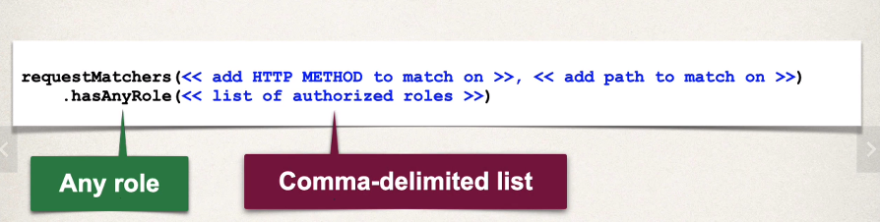

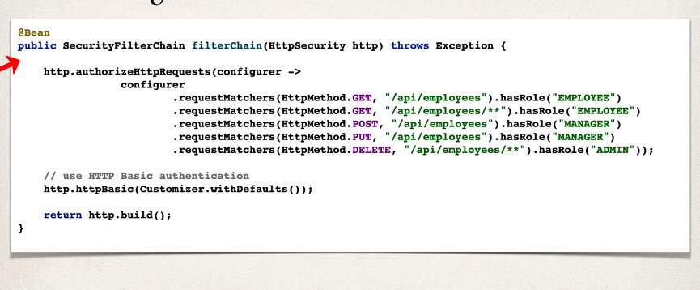

securityfilterchain

Cross-Site Request Forgery (CSRF)

spring security can protect against csrf attacks

embed additional auth data/token into all html forms

on subsequent requests, web app will verify token before processing

primary use case is traditional web apps

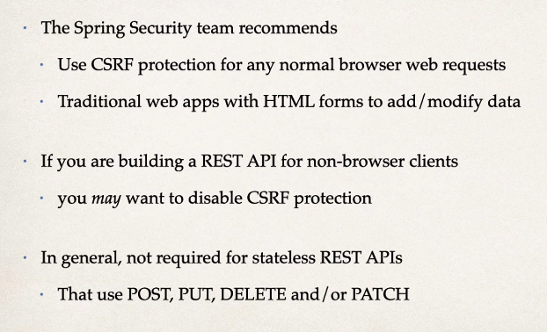

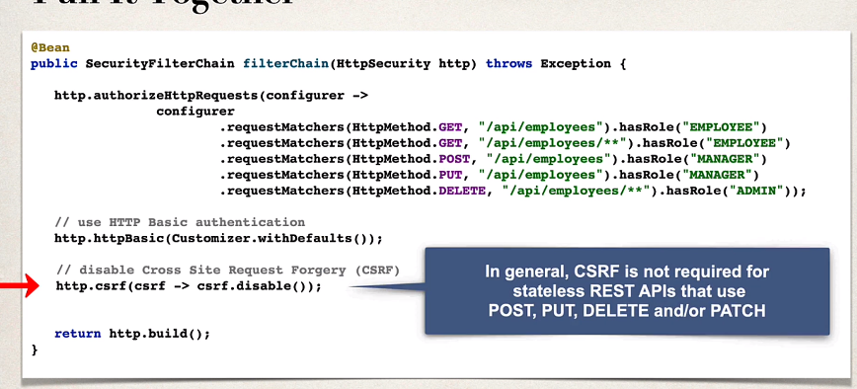

**lesson.148 jdbc authentication**

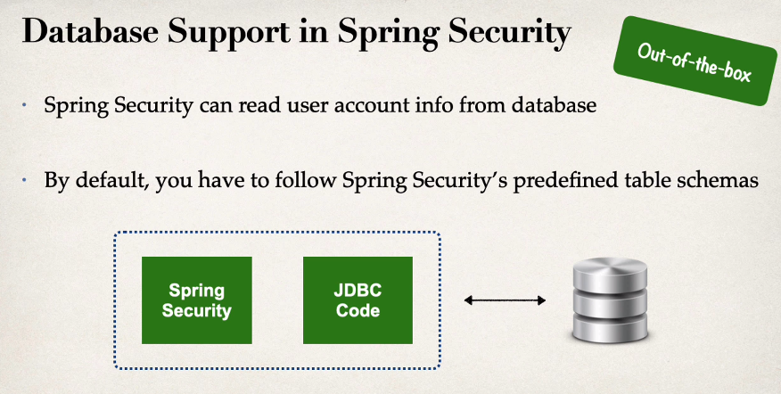

how to implement:

1. develop sql script to set up database tables

2. add db support to maven pom.xml

3. create jdbc properties file

4. update spring sec. confg.

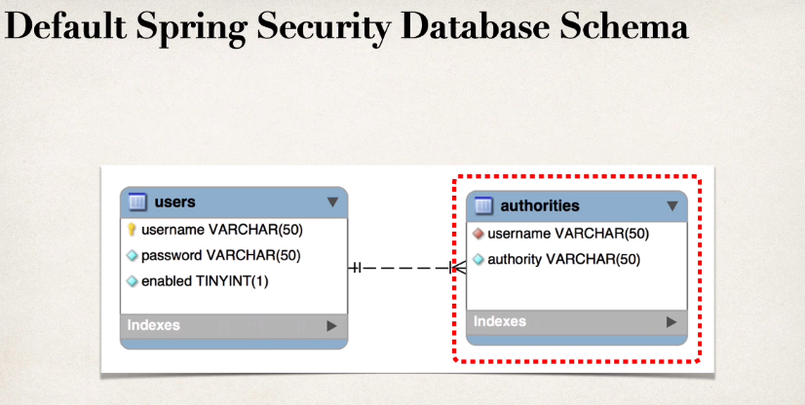

it has to be exact

authorities = roles (employee, admin, manager)

users-> enabled (status of user [active, passive])

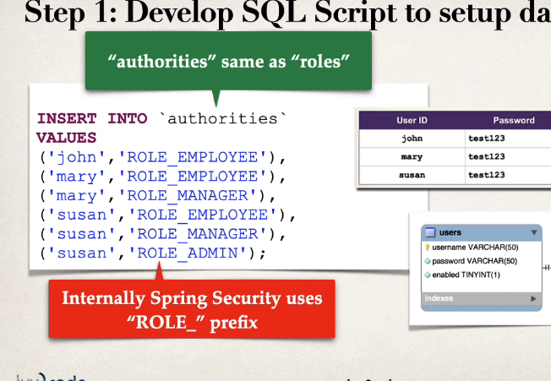

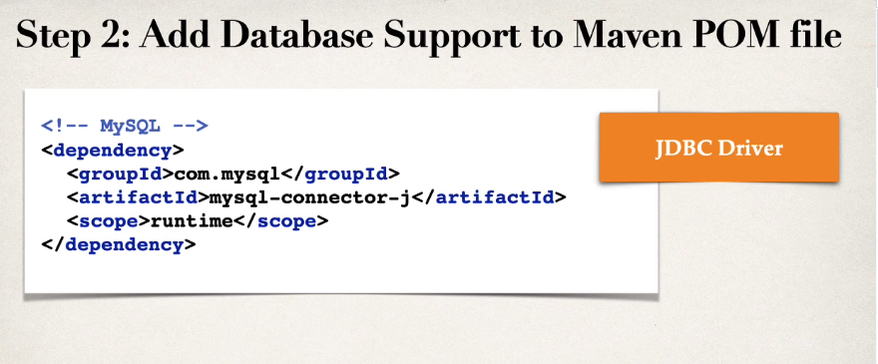

logging.level.org.springframework.security=DEBUG

1. create db tables accordingly (used source file from course)

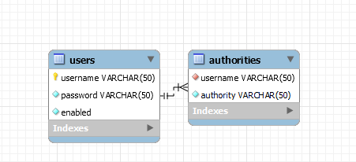

2.comment out previous hardcoded user roles in @Configuration

/*  
@Bean  
public InMemoryUserDetailsManager userDetailsManager()  
{  
 UserDetails john = User.builder()  
 .username("john")  
 .password("{noop}password")  
 .roles("EMPLOYEE")  
 .build();

3. create a new function in @Configuration

//jdbc support  
@Bean  
public UserDetailsManager userDetailsManager(DataSource dataSource)  
{  
 return new JdbcUserDetailsManager(dataSource);  
}

datasource injects itself

(maven automatically added mysql-connector-j dependency or it was already present)

**lesson.152 bCrypt password storage**

{noop} password storage is inappropriate for production

best course is to store encrypted password

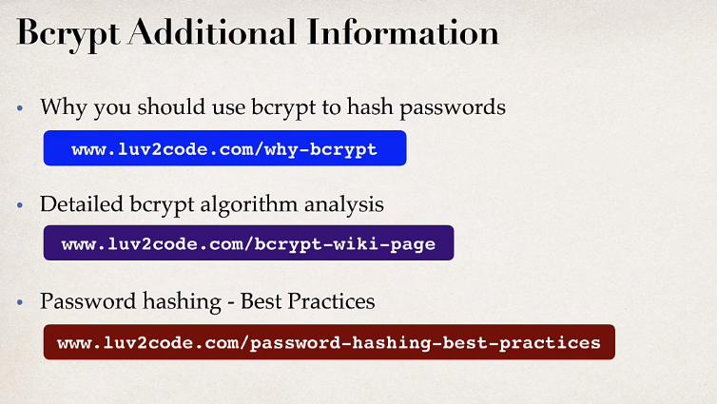

implementation:

run sql script that contains encrypted passwords

modify table because password field needs at least 68 characters

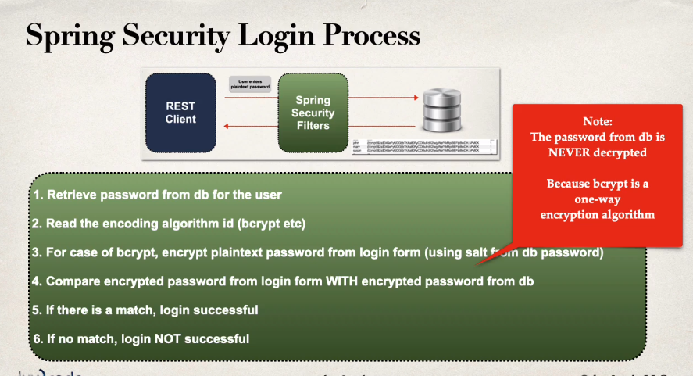

**lesson.155 spring security auth with custom tables**

1. tell spring how to query your custom tables

2. provide query to find user by username

3. provide query to find auths/roles by username

//jdbc support  
@Bean  
public UserDetailsManager userDetailsManager(DataSource dataSource)  
{  
 JdbcUserDetailsManager jdbcUserDetailsManager = new JdbcUserDetailsManager(dataSource);  
  
 //define query to get username  
 jdbcUserDetailsManager.setUsersByUsernameQuery(  
 "select user_id,pw, active from members where user_id=?"  
 );  
  
 //define query to get auth/role by username  
  
 jdbcUserDetailsManager.setAuthoritiesByUsernameQuery(  
 "select user_id, role from roles where user_id=?"  
 );  
  
 return jdbcUserDetailsManager;  
}

**NOTE:** these settings don't work with jpa/hibernate (DAO), check bonus lecture

**ep.6**

**lesson.162 thymeleaf**

thymeleaf is a templating engine commonly used to generate html views for web apps

can be used outside web apps

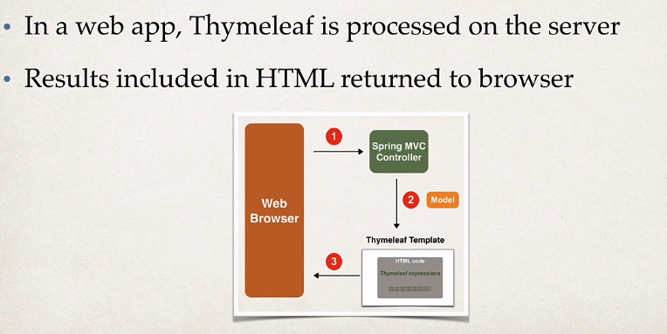

implementation: add thymeleaf as dependency

**demo**

@Controller  
public class DemoController {  
  
 //create mapping for "/hello"  
  
 @GetMapping("/hello")  
 public String sayHello(Model theModel)  
 {  
 theModel.addAttribute("theDate", new java.util.Date());  
  
  
 return "helloWorld";  
 }  
  
}

@Controller instead of @RestController

<!DOCTYPE HTML>  
<html xmlns:th="http://www.thymeleaf.org">  
  
<head>  
 <title> Thymeleaf Demo</title>  
 <!-- reference CSS file -->  
 <link rel="stylesheet" th:href="@{/css/demo.css}"/>  
</head>  
  
<body>  
  
<p th:text ="'Time on the server is ' + ${theDate}" class="funny" />  
  
</body>  
  
</html>

/src/main/resources/templates/helloworld.html

return string "helloWorld" should match with the name "helloworld.html"

.funny{  
 font-style: italic;  
 color: green;  
}

/src/resources/static/css/demo.css

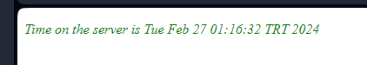

result (static)

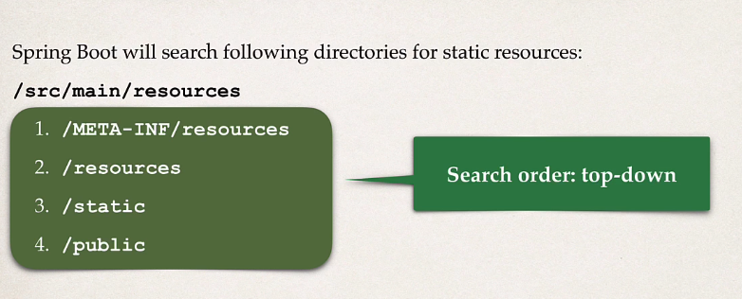

**lesson.167 spring mvc bts**

components of a spring mvc application

.set of web pages

.a collection of spring beans (controllers, services ..)

.spring config. (xml, annotations or java)

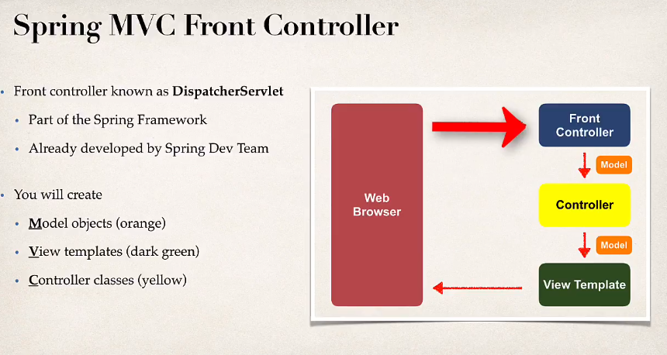

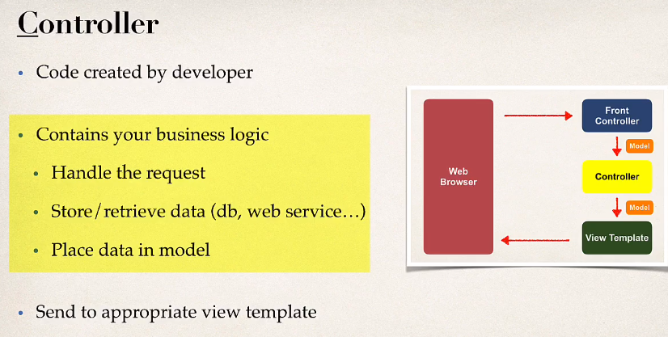

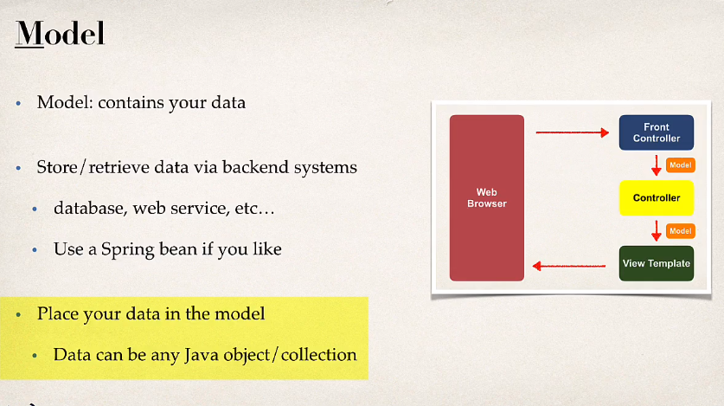

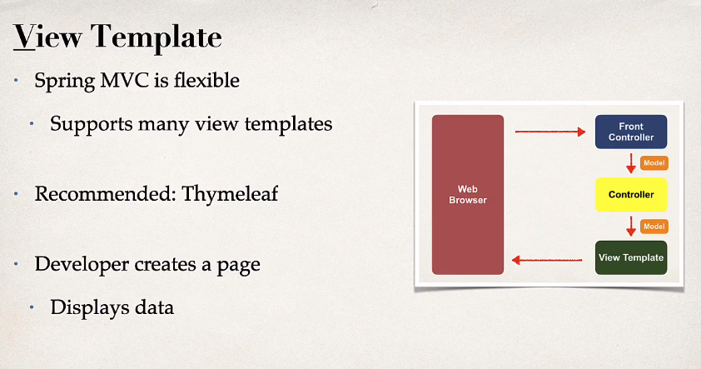

**lesson.168 helloworld form**

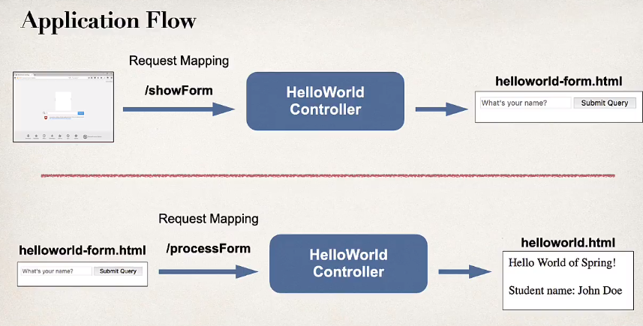

implementation:

@Controller  
public class HelloWorldController {  
  
  
 // controller method: show initial form  
  
 @RequestMapping("/showForm")  
 public String showForm() {  
 return "helloworld-form";  
 }

<!DOCTYPE HTML>  
<html xmlns:th="http://www.thymeleaf.org">  
  
<head>  
 <meta charset="UTF-8">  
 <title>Hello World - Input Form</title>  
</head>  
<body>  
  
 <form th:action="@{/processForm}" method="GET">  
  
 <input type="text" name="studentName" placeholder="what's your name"/>  
 <button>click</button>  
 </form>  
  
 <!-- <button th:onclick="|window.location.href='/processForm'|"/> -->  
</body>  
</html>

helloworld-form.html

browser acesses to the endpoint /showForm which returns "helloworld-form" and since thymeleaf is integrated spring will use helloworld-form.html in ../resources/templates.

helloworld-form has a form tag with th:action="@{/processForm}" in it which means when form is submitted thymeleaf will access to endpoint /processForm (defined in controller)

@RequestMapping("/processForm")  
public String processForm()  
{  
 return "helloworld";  
}

<!DOCTYPE HTML>  
<html xmlns:th="http://www.thymeleaf.org">  
  
<head>  
 <title>Hello World</title>  
 <!-- reference CSS file -->  
  
</head>  
  
<body>  
  
Hello World of Spring  
  
<br><br>  
  
Student name: <span th:text="${param.studentName}"></span>  
  
  
</body>  
  
</html>

helloworld.html

studentName is the name of input box

**lesson.171 model**

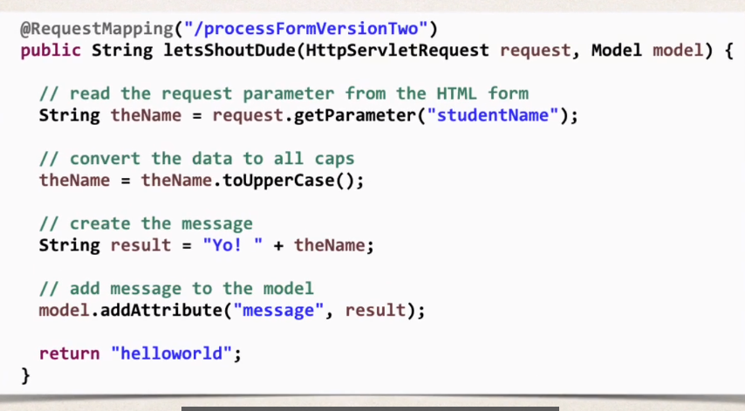

httpservletrequest holds http form data

model is the container for data (initially empty)

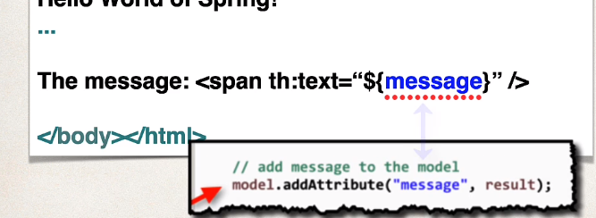

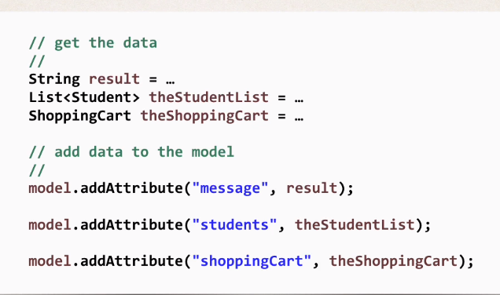

**lesson.174 @RequestParam**

@RequestMapping("/processFormV3")  
public String processFormV3(@RequestParam("studentName") String theName, Model model)  
{  
 //convert to all uppercase  
 theName = theName.toUpperCase();  
 String result = "HI AGAIN " + theName;  
 //add message to the model  
 model.addAttribute("message", result);  
  
 return "helloworld";  
}

instead of getting data from httpservletreq.. we can use @RequestParam annotation which finds and binds the http form data

**lesson.176 GET and POST**

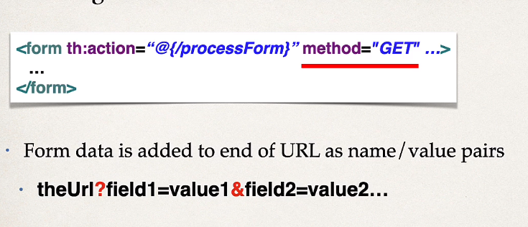

@RequestMapping(path="/var", method=RequestMethod.GET) = @GetMapping("/var")

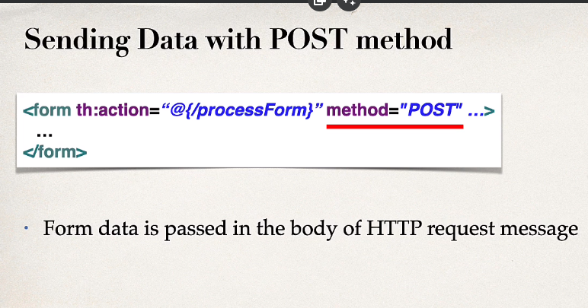

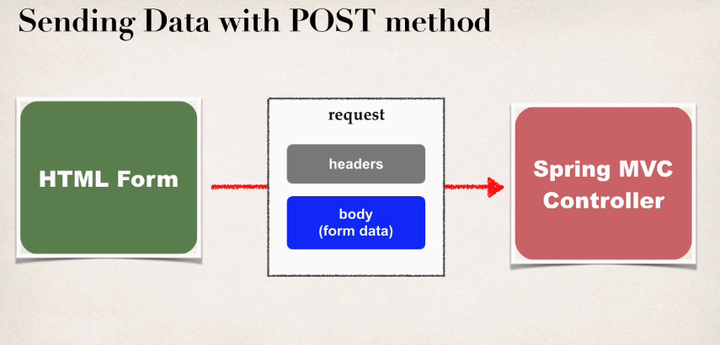

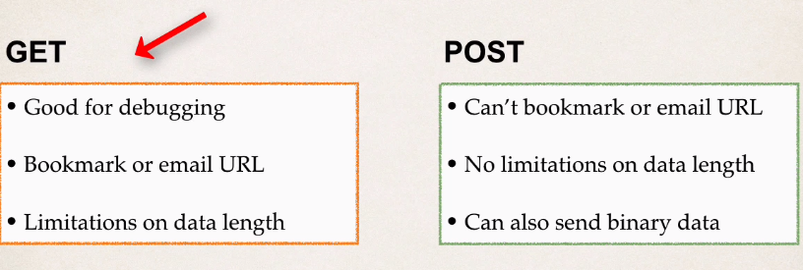

limitations on data length = ~1000 characters

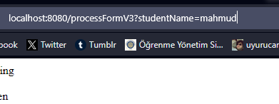

GET request

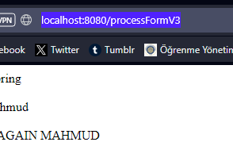

POST request

**lesson.179 form data binding**

instead of getting individual parameters model can be used

before showing form model attr must be added

model attr will hold form data for the data binding

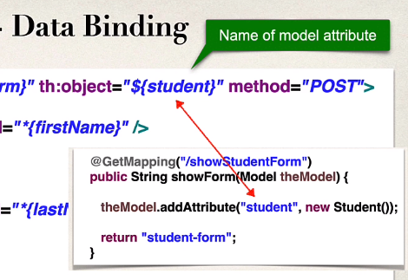

form.html

@GetMapping("/showStudentForm")  
public String showForm(Model theModel)  
{  
 //create Student object  
 Student theStudent = new Student();  
  
 //add to model as attr  
 theModel.addAttribute("student", theStudent);  
  
 theModel.addAttribute("countries",countries);  
  
 theModel.addAttribute("languages",languages);  
  
 theModel.addAttribute("systems",systems);  
 return "student-form";  
}

controller

attributes are added using alias and data, which can be accessed

by thymeleaf using ${student}

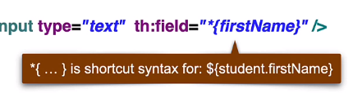

form.html

<form th:action="@{/processStudentForm}" th:object="${student}" method="POST">  
  
 First name: <input type="text" th:field="*{firstName}"/>  
  
 <br><br>  
  
 Last name: <input type="text" th:field="*{lastName}"/>

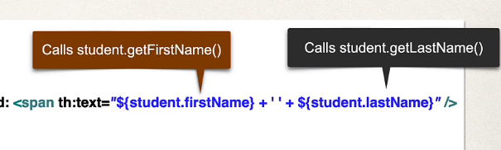

hello.html

**lesson.183 dropdown list**

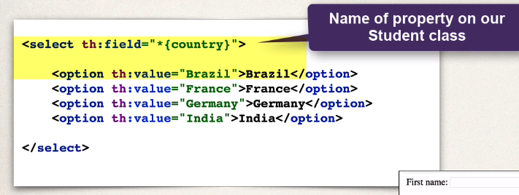

in the example above, options are hardcoded which is not appropriate, alternative method should be:

countries = Brazil,Germany,India,Spain,United States,Turkey

countries are declared in application.properties

@Value("${countries}")  
private List<String> countries;

injected to controller using @Value

@GetMapping("/showStudentForm")  
public String showForm(Model theModel)  
{  
 //create Student object  
 Student theStudent = new Student();  
  
 //add to model as attr  
 theModel.addAttribute("student", theStudent);  
  
 theModel.addAttribute("countries",countries);

added as an attribute in first endpoint function

<select th:field="*{country}">  
 <option th:each="tempCountry : ${countries}" th:value="${tempCountry}" th:text="${tempCountry}"></option>  
</select>

in html, elements are iterated using th:each loop

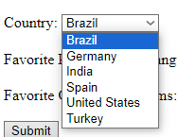

result

**lesson.187 radio list**

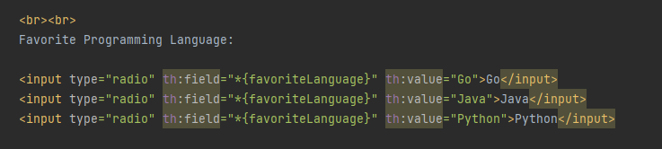

same as lesson.183



result

**lesson.188 checkbox**

everything is the same, except there are multiple checkboxes

Favorite Operating Systems:  
<input type="checkbox" th:field="*{favoriteSystems}"  
 th:each="system : ${systems}"  
 th:value="${system}" th:text="${system}">

html

private List<String> favoriteSystems;

data is declared as string list

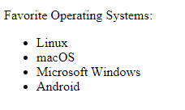result. thymeleaf adds every checkbox value to the list without extra code

Favorite Operating Systems:  
 <ul>  
 <li th:each="tempSystem : ${student.favoriteSystems}" th:text="${tempSystem}"></li>  
 </ul>

html code of the result (above)

**lesson.192 validation**

@NotNull(message = "is required")  
@Size(min = 1, message = "is required")  
private String lastName;

constraint annotations are added to the field of the class

after customer form is submitted, target endpoint checks binding errors

@PostMapping("/processForm")  
 public String processCustomerForm(@Valid @ModelAttribute("customer") Customer theCustomer,  
 BindingResult theBindingResult)  
 {  
 //System.out.println("last name: **" + theCustomer.getLastName() + "**");  
  
 if(theBindingResult.hasErrors())  
 {  
 System.*out*.println(theBindingResult.toString());  
 return "customer-form";  
 }  
 else  
 return "customer-confirmation";  
 }  
  
}

controller

if there are binding errors target endpoint returns input form back

Last name (*): <input type="text" th:field="*{lastName}"/>  
  
<span th:if="${#fields.hasErrors('lastName')}"  
 th:errors="*{lastName}"  
 class="error"/>  
<br><br>

if there are errors regarding field <span> will show up

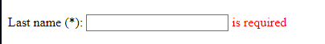

<head>  
 <meta charset="UTF-8">  
 <title>Customer Form</title>  
  
 <style>  
 .error {color:red}  
 </style>  
  
</head>

class error is a short css spec

**lesson.200 @InitBinder**

on previous lesson, validation couldn't check whitespace characters and accepted as notnull, in order to prevent this @InitBinder should be used.

@InitBinder works as a pre-processor

it will pre-process each web request to controller

function declared with @InitBinder will be executed

@InitBinder  
public void initBinder(WebDataBinder webDataBinder)  
{  
 StringTrimmerEditor editor = new StringTrimmerEditor(true);  
 webDataBinder.registerCustomEditor(String.class, editor);  
}

**lesson.206 required integer fields**

@NotNull(message = "is required")  
@Min(value = 0, message = "can not be less than 0")  
@Max(value = 10, message = "can not be larger than 10")  
private int freePasses;

freePasses field is annotated with @notnull



but when input field is empty project assumes field is string and gives corresponding error

in order to avoid this field can be Integer instead of int

**lesson.208 custom error messages**



when string is given to integer input field this error will show up, which is long and unconvenient

in order to set custom error messages, first check bindingresult logs

System.*out*.println(theBindingResult.toString());

Field error in object 'customer' on field 'freePasses': rejected value [sdf]; codes [typeMismatch.customer.freePasses,typeMismatch.freePasses,typeMismatch.java.lang.Integer,typeMismatch]; arguments [org.springframework.context.support.DefaultMessageSourceResolvable: codes [customer.freePasses,freePasses]; arguments []; default message [freePasses]]; default message [Failed to convert property value of type 'java.lang.String' to required type 'java.lang.Integer' for property 'freePasses'; For input string: "sdf"]

typeMismatch.customer.freePasses along with typeMismatch.freePasses typeMismatch.java.lang.Integer,typeMismatch defines this error (from spesific to general)

steps:

create messages.properties file under /resources

typeMismatch.customer.freePasses = only numbers '[0-9]'

add custom message

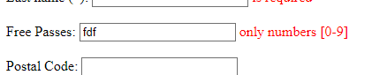

**lesson.209 custom validation**

@Constraint(validatedBy = CourseCodeConstraintValidator.class)  
@Target({ElementType.*FIELD*, ElementType.*METHOD*})  
@Retention(RetentionPolicy.*RUNTIME*)  
public @interface CourseCode {  
  
 //define default course code  
 public String value() default "LUV";  
  
 //define default error message  
 public String message() default "must start with LUV";  
  
 //define default groups  
 public Class<?>[] groups() default {};  
  
 //define default payloads  
 public Class<? extends Payload>[] payload() default {};  
  
  
}

value is going to be used as @CourseCode(value="LUV")

groups can group related constraints

payload: provide custom details about validation failure (severity level, error code etc)

public class CourseCodeConstraintValidator implements ConstraintValidator<CourseCode,String> {  
  
 private String coursePrefix;  
  
 @Override  
 public void initialize(CourseCode constraintAnnotation) {  
 coursePrefix = constraintAnnotation.value();  
 }  
  
 @Override  
 public boolean isValid(String value, ConstraintValidatorContext context) {  
  
 if(value != null)  
 {  
 boolean result = value.startsWith(coursePrefix);  
 return result;  
 }  
 else  
 {  
 return true;  
 }  
 }  
}

validator

**ep.7**

**lesson.219 crud database project - html**

<meta name="viewport" content="width=device-width, initial-scale=1">  
<link href="https://cdn.jsdelivr.net/npm/bootstrap@5.3.3/dist/css/bootstrap.min.css" rel="stylesheet"  
 integrity="sha384-QWTKZyjpPEjISv5WaRU9OFeRpok6YctnYmDr5pNlyT2bRjXh0JMhjY6hW+ALEwIH" crossorigin="anonymous">

import bootstrap in <head>

<table class="table table-bordered table-striped">  
 <thead class="table-dark">  
 <tr>  
 <th>First Name</th>  
 <th>Last Name</th>  
 <th>E-mail</th>  
 <th>Action</th>  
 </tr>  
 </thead>  
 <tbody>  
 <tr th:each="tempEmployee : ${employees}">  
 <td th:text="${tempEmployee.firstName}"/>  
 <td th:text="${tempEmployee.lastName}"/>  
 <td th:text="${tempEmployee.email}"/>  
 <td>  
 <a th:href="@{/employees/update(employeeId=${tempEmployee.id})}" class="btn btn-outline-info btn-sm">Update</a>  
 <a th:href="@{/employees/delete(employeeId=${tempEmployee.id})}" class="btn btn-outline-danger btn-sm"  
 onclick="if(!(confirm('are you sure?') ) ) return false">  
 Delete</a>  
 </td>  
 </tr>  
 </tbody>  
  
  
</table>

table

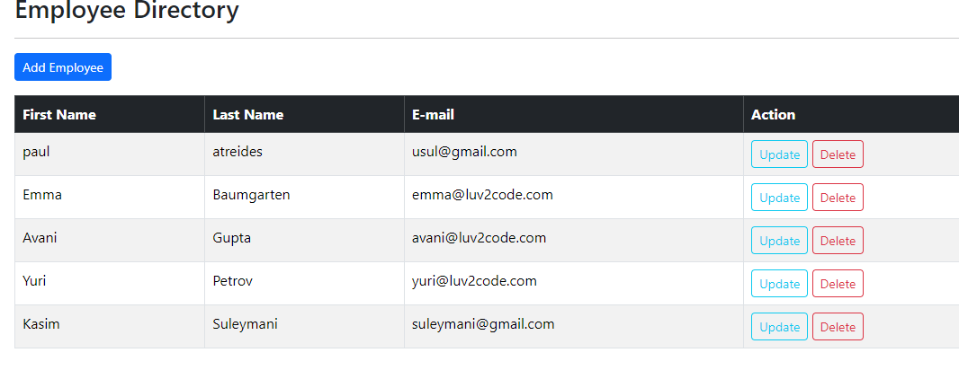

tr : table row

td: table data (cell)

thead: table head

th: table header

tbody: table body

<table>

<thead>

<tr>

<th>header1</th>

<th>header2</th>

<th>header3</th>

</tr>

</thead>

<tbody>

<tr>

<td>data1</td>

<td>data2</td>

<td>data3</td>

<tr>

</tbody>

</table>

(in this project thymeleaf uses one row in a loop)

th:each="temp : ${employees} -> employees is a list<Employee>

**lesson.221**

<meta http-equiv="refresh"  
 content="0; URL='employees/list'">

index.html

this html snippet redirects main page (/) to employees list. index.html is the default page when client accesses to (/)

@GetMapping("/list")  
public String listEmployees(Model theModel)  
{  
 List<Employee> employees = employeeService.findAll();  
 theModel.addAttribute("employees",employees);  
  
 return "employees/list-employees";  
}

controller function for table html

@RequestMapping("/employees")

class annotation

**lesson.222 add a new employee**

<a class="btn btn-primary btn-sm mb-3" th:href="@{/employees/new}">  
 Add Employee  
</a>

list.html

add a new button(link) to new employee form page

<div class="container">  
 <h3>Employee Directory</h3>  
 <hr>  
 <p class="h4 mb-4">Save Employee</p>  
 <form action="#" th:action="@{/employees/save}"  
 th:object="${employee}" method="POST" >  
  
 <input type="hidden" th:field="*{id}">  
  
 <input type="text" th:field="*{firstName}" class="form-control mb-4 w-75 " placeholder="first name">  
 <input type="text" th:field="*{lastName}" class="form-control mb-4 w-75" placeholder="last name">  
 <input type="text" th:field="*{email}" class="form-control mb-4 w-75 " placeholder="e-mail">  
  
 <button type="submit" class="btn btn-info col-2">Save</button>  
 </form>  
 <hr>  
 <a th:href="@{/employees/list}">Back to Employees List</a>  
</div>

hidden id helps with update function (later course)

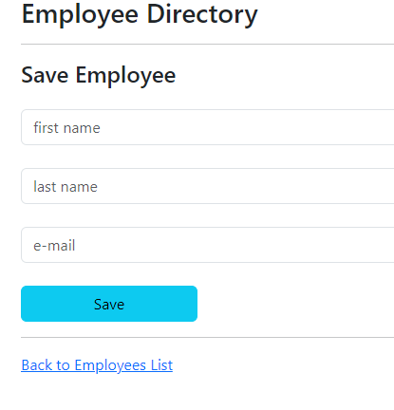

@GetMapping("/new")  
public String addEmployee(Model theModel)  
{  
 Employee employee = new Employee();  
 theModel.addAttribute("employee", employee);  
 return "employees/employee-form";  
}

controller method for new employee

@PostMapping("/save")  
public String save(@ModelAttribute("employee") Employee employee)  
{  
 employeeService.save(employee);  
 //post-redirect-get pattern (prg -- check )  
 return "redirect:/employees/list";  
}

save method

redirect:/.. is used to prevent duplicate request being sent due to interruption/reload, this technique belongs to prg pattern, please check

**lesson.226 update employee**

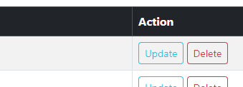

<td>  
 <a th:href="@{/employees/update(employeeId=${tempEmployee.id})}" class="btn btn-outline-info btn-sm">Update</a>

table rows are in iteration by thymeleaf and tempemployee holds info of selected row. update button is referenced to /update endpoint with id information (employeeId=${tempEmployee.id}) which looks like this: 

@GetMapping("/update")  
public String updateEmployee(@RequestParam("employeeId") int id, Model theModel)  
{  
 Employee employee = employeeService.findById(id);  
 theModel.addAttribute("employee",employee);  
  
 return "/employees/employee-form";  
}

controller method for update

update method gets id using @RequestParam. adds corresponding entity to the model (notice: /new controller also added empty object with the same name)

returns employee-form (which is also used for new employee)

<form action="#" th:action="@{/employees/save}"  
 th:object="${employee}" method="POST" >  
  
 <input type="hidden" th:field="*{id}">  
  
 <input type="text" th:field="*{firstName}" class="form-control mb-4 w-75 " placeholder="first name">

employee form has object attrs as field and when accessed inputs fields appear filled with those attrs

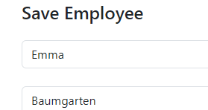

**lesson.228 delete employee**

similar with update, button href to /delete and controller gets id using @RequestParam and removes entity, redirect:/list

new ep

**ep.8**

**lesson.230 spring mvc security**

user login is based on "web browser session" which means when browser is not closed user will stay logged in (spring security)

authentication: has client logged in

authorization: does client have credentials to access

**lesson.238 custom login page**

1. modify spring sec. config to reference custom login form

2. develop a controller to show custom login form

3. create custom login form (html /and css)

**1.**

@Bean  
SecurityFilterChain securityFilterChain(HttpSecurity httpSecurity) throws Exception {  
  
 httpSecurity.authorizeHttpRequests(configurer ->  
 //any request must be authenticated  
 configurer.anyRequest().authenticated()  
 )  
 .formLogin(form ->  
 form  
 .loginPage("/loginPage")  
 .loginProcessingUrl("/authUser")  
 //allow every request  
 .permitAll()  
 );  
  
 return httpSecurity.build();  
}

@Configuration DemoSecurityConfig

endpoint name and url is custom

controller request mapping for authUser is not required. spring will handle

**2.**

@Controller  
public class LoginController {  
  
  
 @GetMapping("/loginPage")  
 public String getLoginPage()  
 {  
 return "login-page";  
 }  
}

**3.**

<html xmlns:th="http://www.thymeleaf.org">  
<head>  
 <meta charset="UTF-8">  
 <title>Custom Login Page</title>  
</head>  
<body>  
<h2>Authentication Required</h2>  
  
<form th:action="@{/authUser}" method="POST">  
 <div th:if="${param.error}">  
 <i>bad credentials</i>  
 </div>  
 <p>  
 username: <input type="text" name="username">  
  
 </p>  
  
 <p>  
 password: <input type="password" name="password">  
 </p>  
  
 <input type="submit" value="Login">  
</form>  
  
</body>  
</html>

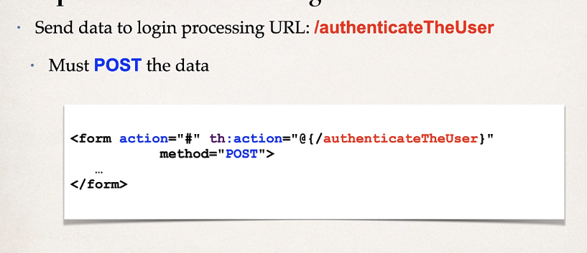

input names MUST be username and password

<div th:if="${param.error}">  
 <i>bad credentials</i>  
</div>

shows error message

**context path**

th:action="@{/}" @ means dynamic context path (localhost in this case)

**lesson.244 custom login page with bootstrap**

download pre-set html page, patch some parts

**lesson.246 session logout**

1. add logout support to spring security config

2. add logout button

3. update login form to display logged out message

**1. fill**

**lesson.248 show user id and roles**

xmlns:sec="http://www.thmyleaf.org/extras/spring-security">

add that into <html

User: <span sec:authentication="principal.username"></span>  
<br><br>  
Role: <span sec:authentication="principal.authorities"></span>

use this

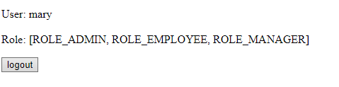

result

**lesson.250 restrict endpoints**

@Bean  
SecurityFilterChain securityFilterChain(HttpSecurity httpSecurity) throws Exception {  
  
 httpSecurity.authorizeHttpRequests(configurer ->  
  
 configurer  
 .requestMatchers("/").hasRole("EMPLOYEE")  
 .requestMatchers("/leaders/**").hasRole("MANAGER")  
 .requestMatchers("/systems/**").hasRole("ADMIN")  
 .anyRequest().authenticated()  
 )  
 .formLogin(form

on @Configuration

if .anyRequest().authenticated() does not exist browser throws http 403 not authorized response

if it exists spring returns the error

**lesson.255 custom access denied page**

httpSecurity.authorizeHttpRequests(configurer -> ...code...)

.exceptionHandling(handler ->  
 handler.accessDeniedPage("/access-denied")  
);

@configuration

create corresponding getmapping and thmyleaf page

**lesson.258 display content based on roles**

<div sec:authorize="hasRole('MANAGER')">  
 <a th:href="@{/leaders}">Leadership Meeting</a>  
 (Only for Managers)  
 <hr>  
</div>

use sec:authorize="hasRole('ROLE')"

**lesson.261 jdbc authentication**

@Bean  
public UserDetailsManager userDetailsManager(DataSource dataSource)  
{  
 return new JdbcUserDetailsManager(dataSource);  
}

change user source

spring.datasource.url=jdbc:mysql://localhost:3306/employee_directory  
spring.datasource.username=springstudent  
spring.datasource.password=springstudent

connect database

<dependency>  
 <groupId>org.springframework.boot</groupId>  
 <artifactId>spring-boot-starter-data-jpa</artifactId>  
</dependency>  
<dependency>  
 <groupId>com.mysql</groupId>  
 <artifactId>mysql-connector-j</artifactId>  
 <version>8.3.0</version>  
</dependency>

import dependencies

**ep.9**

**lesson.274 jpa/hibernate advanced mappings**

mappings- one to many, many to many, many to one

means two or different tables exist and spring must handle these type of situations

primary key: unique row in a table

foreign key: unique row in a table which is also primary key in another table

link tables together

cascade: apply the same operation to related entities

example: save operation on table1 also cascades to save operation on table2

fetch types: eager vs lazy

eager will retrieve everything (all related entities)

lazy will retrieve on demand

uni-directional : table1 to table2

bi-directional: table1 to table2 and also table2 to table1

**lesson.276 @OneToOne mapping**

instructor -> instructor_detail

uni-directional

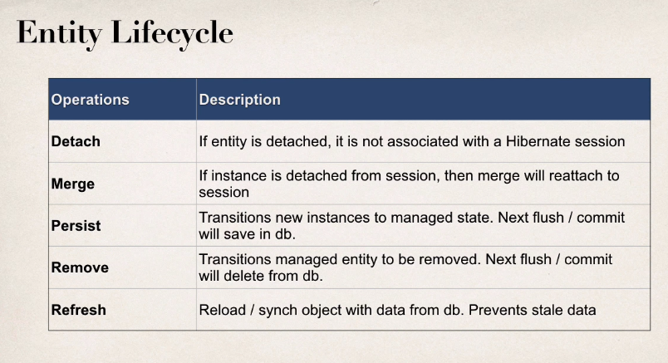

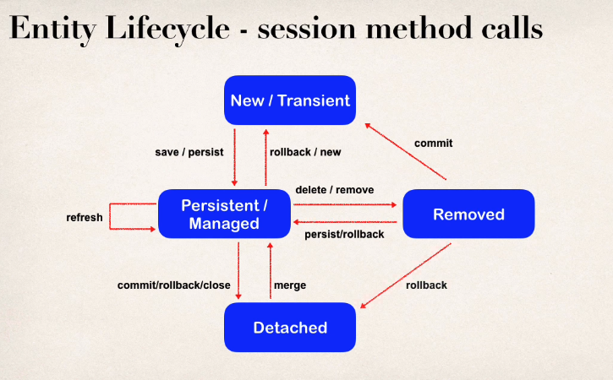

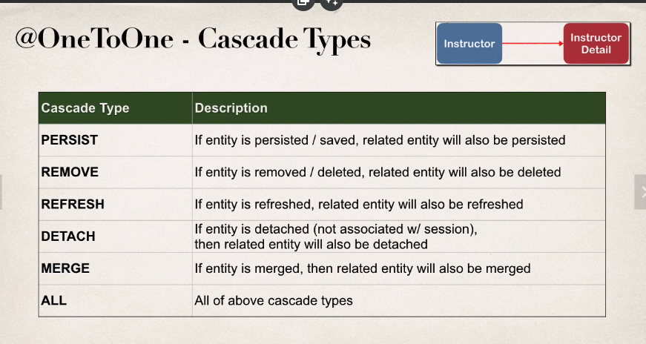

if cascade isn't defined, operations will not cascade

**lesson.282 @onetoone example**

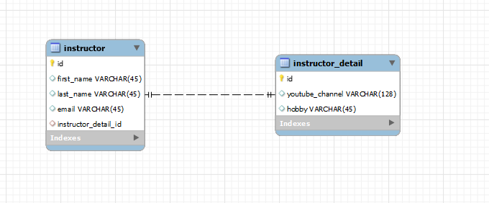

create db schema

SET FOREIGN_KEY_CHECKS = 0;

CREATE TABLE `instructor_detail` (

`id` int NOT NULL AUTO_INCREMENT,

`youtube_channel` varchar(128) DEFAULT NULL,

`hobby` varchar(45) DEFAULT NULL,

PRIMARY KEY (`id`)

) AUTO_INCREMENT=1

CREATE TABLE `instructor` (

`id` int NOT NULL AUTO_INCREMENT,

`first_name` varchar(45) DEFAULT NULL,

`last_name` varchar(45) DEFAULT NULL,

`email` varchar(45) DEFAULT NULL,

`instructor_detail_id` int DEFAULT NULL,

PRIMARY KEY (`id`),

KEY `FK_DETAIL_idx` (`instructor_detail_id`),

CONSTRAINT `FK_DETAIL` FOREIGN KEY (`instructor_detail_id`) REFERENCES `instructor_detail` (`id`) ON DELETE NO ACTION ON UPDATE NO ACTION

) AUTO_INCREMENT=1 DEFAULT

SET FOREIGN_KEY_CHECKS = 1;

primary key of instructor_detail (id) is foreign key of instructor(instructor_detail_id)

@Bean  
public CommandLineRunner commandLineRunner(AppDAO dao)  
{  
 return runner ->  
 {  
 createInstructor(dao);  
 };  
}

command line runner is used (for simplicity)

@Entity  
@Table(name = "instructor_detail")  
public class InstructorDetail {  
  
 @Column(name = "id")  
 @Id  
 @GeneratedValue(strategy = GenerationType.*IDENTITY*)  
 int id;  
  
 @Column(name = "youtube_channel")  
 String youtubeChannel;  
  
 @Column(name = "hobby")  
 String hobby;  
  
 public InstructorDetail() {}

create instructorDetail (getters and setters and tostring)

@Entity  
@Table(name = "instructor")  
public class Instructor {  
  
 @Column(name = "id")  
 @Id  
 @GeneratedValue(strategy = GenerationType.*IDENTITY*)  
 private int id;  
  
 @Column(name = "first_name")  
 private String firstName;  
  
 @Column(name = "last_name")  
 private String lastName;  
  
 @Column(name = "email")  
 private String email;  
  
 //set up mapping to instructor detail  
  
 @OneToOne(cascade = CascadeType.*ALL*)  
 @JoinColumn(name = "instructor_detail_id")  
 private InstructorDetail instructorDetail;  
  
 public Instructor() {}

create instructor class (getters and setters and tostring)

there is an instructorDetail variable in the instructor class that is annotated as @OneToOne(cascade =..) (check cascade types above)

and @JoinColumn(name = "instructor_detail_id") which tells spring how to join these two tables together

private void createInstructor(AppDAO dao) {  
   
 //create instructor  
 Instructor tempInstructor = new Instructor("Ugur","Kacar","kucaru1@gmail.com");  
  
 //create instructorDetail  
 InstructorDetail tempDetail = new InstructorDetail("memur","baglama");  
  
 tempInstructor.setInstructorDetail(tempDetail);  
  
 System.*out*.println(tempInstructor);  
  
 dao.save(tempInstructor);  
  
}

save entities

when instructor is saved to db, instructordetail is also saved into detail table

**note:** instructorDetail is saved first because id of the detail is needed in instructor table

**lesson.287 onetoone mapping find an entity**

@Override  
public Instructor findInstructorById(int id) {  
 return entityManager.find(Instructor.class, id);  
}

same as a normal entity

when instructor is found instructordetail is also found (eager approach)

**lesson.288 delete onetoone entity**

same

**lesson.289 @oneToOne mapping - bidirectional**

on uni-directional mapping, instructorDetail object was declared and annotated with @onetoone and @joincolumn in instructor class. no declaration/annotation was done regarding mapping on instructorDetail class.

in order to achieve bidirectional relationship

@OneToOne(mappedBy = "instructorDetail", cascade = CascadeType.*ALL*)  
private Instructor instructor;

instructorDetail

create an instructor variable

annotate with @oneToOne(mappedBy="var")

mappedBy= "instructorDetail" points at the name of object that is in the instructor class

@OneToOne(cascade = CascadeType.*ALL*)  
@JoinColumn(name = "instructor_detail_id")  
private InstructorDetail instructorDetail;

instructor

**lesson.291 findbyInstructorDetail**

@Override  
public InstructorDetail findInstructorDetailById(int id) {  
 return entityManager.find(InstructorDetail.class, id);  
}

2024-05-02T15:48:30.779+03:00 DEBUG 18632 --- [OneToOneDemo] [ main] org.hibernate.SQL : select id1_0.id,id1_0.hobby,i1_0.id,i1_0.email,i1_0.first_name,i1_0.last_name,id1_0.youtube_channel from instructor_detail id1_0 left join instructor i1_0 on id1_0.id=i1_0.instructor_detail_id where id1_0.id=?

**lesson.293 deleting instructorDetail without deleting instructor**

on instructorDetail instead of using CascadeTypes.ALL,

use

@OneToOne(mappedBy = "instructorDetail", cascade = {CascadeType.*DETACH*, CascadeType.*MERGE*, CascadeType.*PERSIST*, CascadeType.*REFRESH*})  
private Instructor instructor;

instructorDetail

@Override  
@Transactional  
public void deleteInstructorById(int id)  
{  
 Instructor instructor = findInstructorById(id);  
 entityManager.remove(instructor);  
}

daoimpl

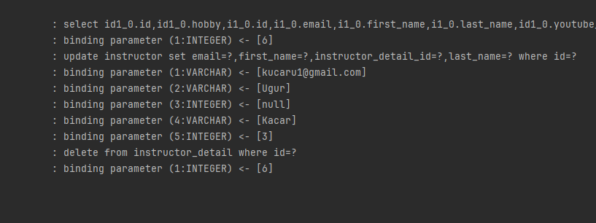

hibernate updates instructor while deleting related instructordetail

**lesson.294 @OneToMany**

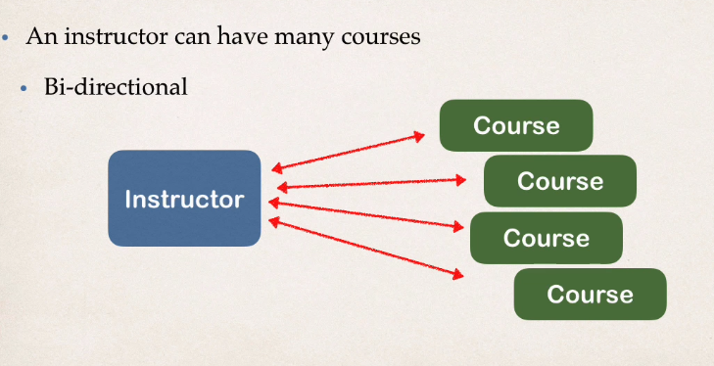

SET FOREIGN_KEY_CHECKS = 0;

DROP TABLE IF EXISTS `instructor_detail`;

CREATE TABLE `instructor_detail` (

`id` int NOT NULL AUTO_INCREMENT,

`youtube_channel` varchar(128) DEFAULT NULL,

`hobby` varchar(45) DEFAULT NULL,

PRIMARY KEY (`id`)

) ENGINE=InnoDB AUTO_INCREMENT=1 DEFAULT CHARSET=latin1;

DROP TABLE IF EXISTS `instructor`;

CREATE TABLE `instructor` (

`id` int NOT NULL AUTO_INCREMENT,

`first_name` varchar(45) DEFAULT NULL,

`last_name` varchar(45) DEFAULT NULL,

`email` varchar(45) DEFAULT NULL,

`instructor_detail_id` int DEFAULT NULL,

PRIMARY KEY (`id`),

KEY `FK_DETAIL_idx` (`instructor_detail_id`),

CONSTRAINT `FK_DETAIL` FOREIGN KEY (`instructor_detail_id`)

REFERENCES `instructor_detail` (`id`) ON DELETE NO ACTION ON UPDATE NO ACTION

) ENGINE=InnoDB AUTO_INCREMENT=1 DEFAULT CHARSET=latin1;

DROP TABLE IF EXISTS `course`;

CREATE TABLE `course` (

`id` int NOT NULL AUTO_INCREMENT,

`title` varchar(128) DEFAULT NULL,

`instructor_id` int DEFAULT NULL,

PRIMARY KEY (`id`),

UNIQUE KEY `TITLE_UNIQUE` (`title`),

KEY `FK_INSTRUCTOR_idx` (`instructor_id`),

CONSTRAINT `FK_INSTRUCTOR`

FOREIGN KEY (`instructor_id`)

REFERENCES `instructor` (`id`)

ON DELETE NO ACTION ON UPDATE NO ACTION

) ENGINE=InnoDB AUTO_INCREMENT=10 DEFAULT CHARSET=latin1;

SET FOREIGN_KEY_CHECKS = 1;

**create database**

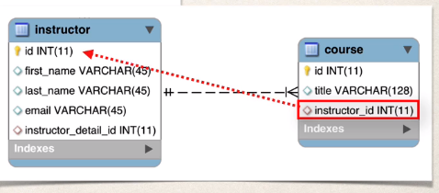

create course class

@ManyToOne(cascade = {CascadeType.*DETACH*, CascadeType.*MERGE*,  
 CascadeType.*PERSIST*, CascadeType.*REFRESH*})  
@JoinColumn(name = "instructor_id")  
private Instructor instructor;

course

create instructor instance

exclude CascadeType.DELETE in order to prevent deleting instructor when course is deleted

@OneToMany(mappedBy = "instructor", cascade = {CascadeType.*DETACH*, CascadeType.*MERGE*,  
 CascadeType.*PERSIST*, CascadeType.*REFRESH*})  
private List<Course> courses;

create list of courses in instructor class

notice annotation is @onetomany instead of @manytoone as it was in course class

(mappedBy = "instructor" -> @JoinColumn(name = "instructor_id")  
 private Instructor instructor;

instructor.java course.java

public void add(Course course)  
{  
 if(courses == null)  
 {  
 courses = new ArrayList<>();  
 }  
  
 courses.add(course);  
  
 course.setInstructor(this);  
}

create adding course method in instructor class

course.setinstructor is used to set a bidirectional relationship

private void createInstrAndCourse(AppDAO dao){  
  
 //create instructor  
 Instructor tempInstructor = new Instructor("Ugur","Kudur","kucaru1@gmail.com");  
  
 //create instructorDetail  
 InstructorDetail tempDetail = new InstructorDetail("memur","baglama");  
  
 tempInstructor.setInstructorDetail(tempDetail);  
  
 //create courses  
 Course tempCourse1 = new Course("HIS101");  
 Course tempCourse2 = new Course("MTH204");  
  
 //add courses to instructor  
  
 tempInstructor.add(tempCourse1);  
 tempInstructor.add(tempCourse2);  
  
 //save instructor  
  
 System.*out*.println("save");  
  
 System.*out*.println(tempInstructor.getCourses());  
  
}

test method

**lesson.302 fetch types - eager vs lazy**

best practice: only load data when absolutely needed (some exceptions)

lazy loading: will load main entity first

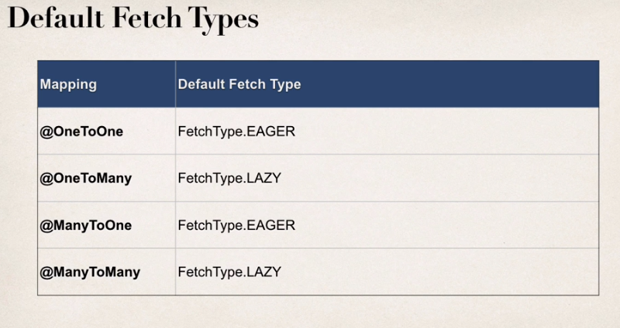

override:

@ManyToOne(fetch=FetchType.Lazy)

in order for lazy fetch type to work properly, hibernate needs to have an active session with the database

**lesson.306 get lazy data**

@OneToMany mapping is default lazy fetch

@Override  
public List<Course> findCoursesByInsId(int id) {  
 TypedQuery<Course> query = entityManager.createQuery("from Course where instructor.id = :data", Course.class);  
 query.setParameter("data", id);  
 return query.getResultList();  
}

dao implementation

create a query to retrieve course data from db

instructor.id is not a variable declared in course, rather it is

@ManyToOne(cascade = {CascadeType.*DETACH*, CascadeType.*MERGE*,  
 CascadeType.*PERSIST*, CascadeType.*REFRESH*})  
@JoinColumn(name = "instructor_id")  
private Instructor instructor;

(which has a id variable)

List<Course> courseList = dao.findCoursesByInsId(id);  
instructor.setCourses(courseList);  
System.*out*.println("courses: "+ instructor.getCourses());

in use

**lesson.308 @OneToMany join fetch**

instead of retrieving tables' data seperately, create one query to get all data by using join fetch (workaround for lazy fetch)

@Override  
public Instructor findInstructorByIDJoinFetch(int id) {  
  
 TypedQuery<Instructor> query = entityManager.createQuery(  
 "select i from Instructor i "  
 + "JOIN FETCH i.courses "  
 // + "JOIN FETCH i.instructorDetail "  
 + "where i.id = :data", Instructor.class);  
  
 query.setParameter("data", id);  
  
 return query.getSingleResult();  
}

dao implementation

difference between JOIN and JOIN FETCH: join only selects table1, whilst join fetch selects table1 and table2 data (for hibernate)

2024-05-10T07:57:29.542+03:00 DEBUG 19620 --- [OneToOneDemo] [ main] org.hibernate.SQL : select i1_0.id,c1_0.instructor_id,c1_0.id,c1_0.title,i1_0.email,i1_0.first_name,i1_0.instructor_detail_id,i1_0.last_name from instructor i1_0 join course c1_0 on i1_0.id=c1_0.instructor_id where i1_0.id=?

2024-05-10T07:57:29.553+03:00 TRACE 19620 --- [OneToOneDemo] [ main] org.hibernate.orm.jdbc.bind : binding parameter (1:INTEGER) <- [1]

2024-05-10T07:57:29.576+03:00 DEBUG 19620 --- [OneToOneDemo] [ main] org.hibernate.SQL : select id1_0.id,id1_0.hobby,i1_0.id,i1_0.email,i1_0.first_name,i1_0.last_name,id1_0.youtube_channel from instructor_detail id1_0 left join instructor i1_0 on id1_0.id=i1_0.instructor_detail_id where id1_0.id=?

2024-05-10T07:57:29.577+03:00 TRACE 19620 --- [OneToOneDemo] [ main] org.hibernate.orm.jdbc.bind : binding parameter (1:INTEGER) <- [1]

hibernate runs two queries; one for instructor join course, other for instructorDetail

if join fetch is also used for instructordetail removes the need for second query

**lesson.313 @OneToMany delete instructor**

@Override  
@Transactional  
public void deleteInstructorById(int id)  
{  
 Instructor instructor = entityManager.find(Instructor.class, id);  
 for(Course course : instructor.getCourses())  
 {  
 course.setInstructor(null);  
 }  
 entityManager.remove(instructor);  
}

if course relationship does not break sql throws contraint violation error (instructor_id column of course is foreign key referenced to instructor)

**lesson.315 onetoMany uni-directional mapping**

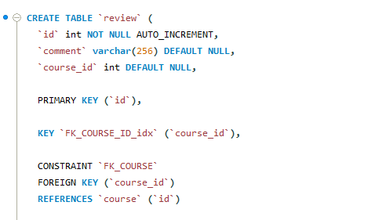

create review table

@Entity  
@Table(name = "review")  
public class Review {  
  
 //define fields  
  
 @Column(name = "id")  
 @Id  
 @GeneratedValue(strategy = GenerationType.*IDENTITY*)  
 private int id;  
  
 @Column(name = "comment")  
 private String comment;  
  
  
 public Review() {}

create review entity

(notice there's no variable for course_id column)

@OneToMany(fetch = FetchType.*LAZY*, cascade = CascadeType.*ALL*)  
@JoinColumn(name = "course_id")  
List<Review> reviews;

Course.java

add review list and annotate with @onetomany and @joincolumn

("name = course_id" references to course_id column **in the review table**)

**note:(apparently) usually onetomany and join column is not used together because hibernate runs multiple queries to insert child elements and update their parent_id field**

**but some devs mention they can be used together when uni-directional mapping is the case**

**note: n+1 query problem: when accessing database, using multiple small queries instead of one complex query creates N+1 query problem because project needs to access db and get results repeatedly which creates delay**

**lesson.322 @ManyToMany mappings**

in order to keep track of mappings there should be a third table "join table"

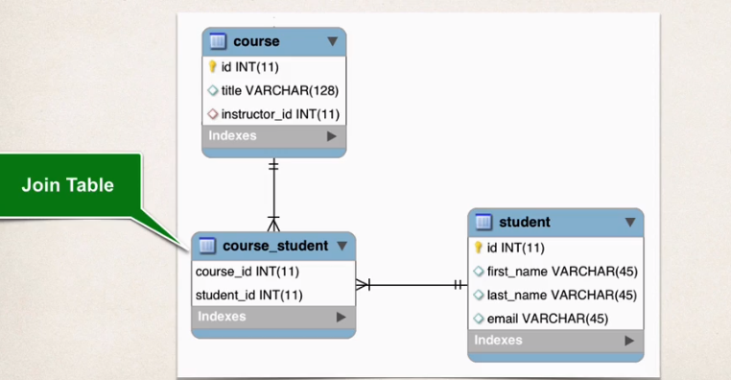

.create db tables

DROP SCHEMA IF EXISTS `hb-05-many-to-many`;

CREATE SCHEMA `hb-05-many-to-many`;

use `hb-05-many-to-many`;

SET FOREIGN_KEY_CHECKS = 0;

CREATE TABLE `instructor_detail` (

`id` int NOT NULL AUTO_INCREMENT,

`youtube_channel` varchar(128) DEFAULT NULL,

`hobby` varchar(45) DEFAULT NULL,

PRIMARY KEY (`id`)

) ENGINE=InnoDB AUTO_INCREMENT=1 DEFAULT CHARSET=latin1;

CREATE TABLE `instructor` (

`id` int NOT NULL AUTO_INCREMENT,

`first_name` varchar(45) DEFAULT NULL,

`last_name` varchar(45) DEFAULT NULL,

`email` varchar(45) DEFAULT NULL,

`instructor_detail_id` int DEFAULT NULL,

PRIMARY KEY (`id`),

KEY `FK_DETAIL_idx` (`instructor_detail_id`),

CONSTRAINT `FK_DETAIL` FOREIGN KEY (`instructor_detail_id`)

REFERENCES `instructor_detail` (`id`) ON DELETE NO ACTION ON UPDATE NO ACTION

) ENGINE=InnoDB AUTO_INCREMENT=1 DEFAULT CHARSET=latin1;

CREATE TABLE `course` (

`id` int NOT NULL AUTO_INCREMENT,

`title` varchar(128) DEFAULT NULL,

`instructor_id` int DEFAULT NULL,

PRIMARY KEY (`id`),

UNIQUE KEY `TITLE_UNIQUE` (`title`),

KEY `FK_INSTRUCTOR_idx` (`instructor_id`),

CONSTRAINT `FK_INSTRUCTOR`

FOREIGN KEY (`instructor_id`)

REFERENCES `instructor` (`id`)

ON DELETE NO ACTION ON UPDATE NO ACTION

) ENGINE=InnoDB AUTO_INCREMENT=10 DEFAULT CHARSET=latin1;

CREATE TABLE `review` (

`id` int NOT NULL AUTO_INCREMENT,

`comment` varchar(256) DEFAULT NULL,

`course_id` int DEFAULT NULL,

PRIMARY KEY (`id`),

KEY `FK_COURSE_ID_idx` (`course_id`),

CONSTRAINT `FK_COURSE`

FOREIGN KEY (`course_id`)

REFERENCES `course` (`id`)

ON DELETE NO ACTION ON UPDATE NO ACTION

) ENGINE=InnoDB AUTO_INCREMENT=1 DEFAULT CHARSET=latin1;

CREATE TABLE `student` (

`id` int NOT NULL AUTO_INCREMENT,

`first_name` varchar(45) DEFAULT NULL,

`last_name` varchar(45) DEFAULT NULL,

`email` varchar(45) DEFAULT NULL,

PRIMARY KEY (`id`)

) ENGINE=InnoDB AUTO_INCREMENT=1 DEFAULT CHARSET=latin1;

CREATE TABLE `course_student` (

`course_id` int NOT NULL,

`student_id` int NOT NULL,

PRIMARY KEY (`course_id`,`student_id`),

KEY `FK_STUDENT_idx` (`student_id`),

CONSTRAINT `FK_COURSE_05` FOREIGN KEY (`course_id`)

REFERENCES `course` (`id`)

ON DELETE NO ACTION ON UPDATE NO ACTION,

CONSTRAINT `FK_STUDENT` FOREIGN KEY (`student_id`)

REFERENCES `student` (`id`)

ON DELETE NO ACTION ON UPDATE NO ACTION

) ENGINE=InnoDB DEFAULT CHARSET=latin1;

SET FOREIGN_KEY_CHECKS = 1;

.create student class

and add list of courses

@ManyToMany(fetch = FetchType.*LAZY*, cascade = {CascadeType.*DETACH*, CascadeType.*MERGE*, CascadeType.*PERSIST*, CascadeType.*REFRESH*})  
@JoinTable(  
 name = "course_student",  
 joinColumns = @JoinColumn(name = "student_id"),  
 inverseJoinColumns = @JoinColumn(name = "course_id")  
)  
private List<Course> courses;

use @JoinTable annotation to address join table

name = depicts the name of join table

for joinColumns use join information of current class (student)

for inverseJoinColumns use join information of other class (course)

dont cascade deletes

public void add(Course course)  
{  
 if(courses == null)  
 {  
 courses = new ArrayList<>();  
 }  
 courses.add(course);  
  
}

add method to add courses to the list

@ManyToMany(fetch = FetchType.*LAZY*, cascade = {CascadeType.*DETACH*, CascadeType.*MERGE*, CascadeType.*PERSIST*, CascadeType.*REFRESH*})  
@JoinTable(name = "course_student",  
 joinColumns = @JoinColumn(name = "course_id"),  
 inverseJoinColumns = @JoinColumn(name = "student_id")  
)  
private List<Student> students;

follow same steps for course.java

course_id for joinColumns and student_id for inverse

tempCourse.add(tempStudent);  
tempCourse.add(tempStudent2);  
//save the course and students  
System.*out*.println("save student and course");  
  
dao.save(tempCourse);

when course is added hibernate handles binding and inserting entries into course, studend and join table

**lesson.330 findCourseandStudents**

@Override  
public Course findCourseAndStudentsById(int id) {  
  
 TypedQuery<Course> query = entityManager.createQuery("SELECT c FROM Course c JOIN FETCH c.students WHERE c.id = :data", Course.class);  
 query.setParameter("data", id);  
  
 return query.getSingleResult();  
}

use join fetch

**lesson.332 add courses to student**

use merge instead of persist

**lesson.333 delete course/student**

@Override  
@Transactional  
public void deleteStudentById(int id) {  
 Student student = entityManager.find(Student.class,id);  
 entityManager.remove(student);  
}

since app does not cascade deletes, it is safe to delete student without accidently deleting courses

**ep.10 aop**

**lesson.336 aop**

programming technique based on concept of an aspect

aspect encapsulates cross-cutting logic(cross-cutting concern)

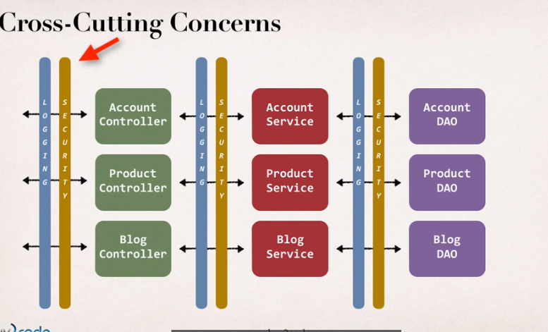

aspect can be reused at multiple locations

**lesson.337 aop concepts and terminology**

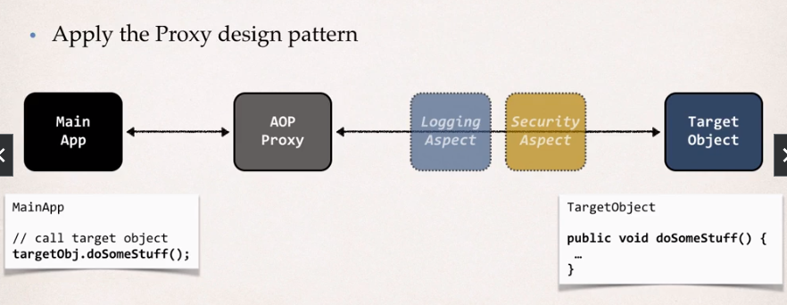

main app does not know proxies and aspects

aop use cases:

logging, security, transactions

audit logging(who, what, when, where)

exception handling

api management

advantages:

reusable modules

resolves code tangling(: spesific code performs multiple functions)

resolves code scatter(: code performing a spesific function is fragmented and repeated)

disadvantages:

too many aspects make app flow hard to follow

minor performance cost

aop terminology:

aspect: module of code for a cross-cutting concern(logging, security)

advice: what action is taken and when it should be applied

join point: when to apply code during execution

pointcut: a predicate exp. for where advice should be applied

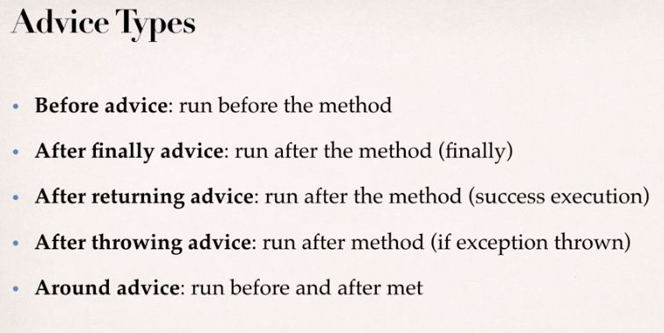

weaving: connecting aspects to target objects to create an advised object

weaving types: compile time, runtime, load time

**lesson.340 @Before advice**

use cases: logging, security, transactions, audit logging, analytics

aop starter:

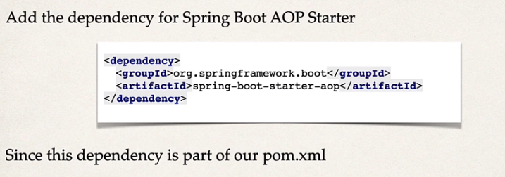

springboot automatically enables support for aop

best practice for aspect and advice:

keep code small and fast

do not perform expensive / slow operations

get in-out quickly as possible

**lesson.342 implementation**

<dependency>  
 <groupId>org.springframework.boot</groupId>  
 <artifactId>spring-boot-starter-aop</artifactId>  
</dependency>

add dependency (doesnt exist in start.spring.io)

public interface AccountDAO {  
  
 void addAccount();  
}

interface

@Repository  
public class AccountDAOImpl implements AccountDAO{  
  
  
 @Override  
 public void addAccount() {  
  
 System.*out*.println(getClass() + " hello");  
 }

impl

@Aspect  
@Component  
public class DemoLoggingAspect {  
  
 @Before("execution(public void addAccount())")  
 public void beforeAddAccountAdvice()  
 {  
 System.*out*.println("\n ######### @before on addAccount() #########");  
 }  
  
}

aspect class

class for aspect gets @Aspect annotation as well as @Component

for the method that will be called is annotated with @Before with pointcut expression

this method will run before every method that has the identity "public void addAccount()"

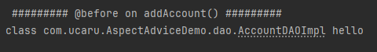

result

**lesson.346 pointcut expressions**

execution(modifiers-pattern? return-type-pattern declaring-type-pattern? method-name-pattern(param-pattern) throws-pattern?)

modifiers-pattern: public, protected

return-type: void, boolean etc

declaring-type: class name

method name

throws-pattern

? means optional

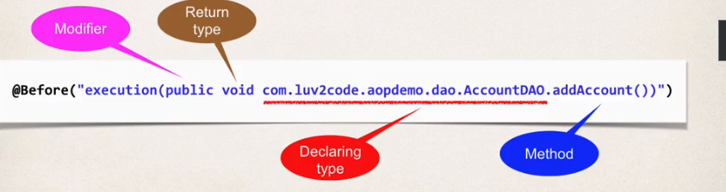

**..wildcards**

@Before("execution(public void add*()") : call for any method starts with "add"

@Before("execution(public * add*()") : call for any return type

@Before("execution(* add*()"):

**lesson.352 pointcut expressions - parameter patterns**

() match with no argument

(*) match with one argument of any type

(..) match with 0 or more arguments of any type

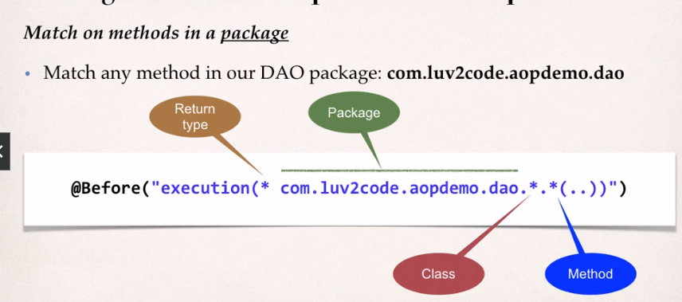

@Before("execution(* add*(com.ucaru.AspectAdviceDemo.Account,..))")

parameters must have full class name

this advice matches with every method starts with "add" and has Account parameter with 0 or more any type of parameters

**lesson.357 pointcut declarations**

in order to use multiple functions for same pointcut adresses, pointcut declaration can be used.

@Pointcut("execution(* com.ucaru.AspectAdviceDemo.*.*.*(..))")  
private void forDaoPackage() {}

@Aspect @Component DemoLoggingAspect.class

create a function and annotate with @PointCut

@Before("forDaoPackage()")  
//@Before("execution(public void com.ucaru.AspectAdviceDemo.dao.AccountDAO.addAccount())")  
public void beforeAddAccountAdvice()  
{  
 System.*out*.println("\n ######### @before on add*() #########");  
}

use as a parameter for @Before annotation

**lesson.360 combine pointcut declarations**

&&, ||, !

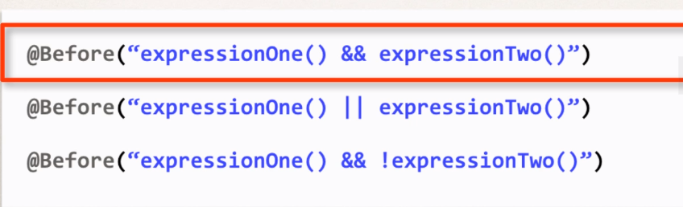

@Pointcut("execution(* com.ucaru.AspectAdviceDemo.dao.*.*(..))")  
private void forDaoPackage() {}  
  
@Pointcut("execution(* com.ucaru.AspectAdviceDemo.dao.*.get*(..))")  
private void getter() {}  
  
@Pointcut("execution(* com.ucaru.AspectAdviceDemo.dao.*.set*(..))")  
private void setter() {}  
  
@Pointcut("forDaoPackage() && !( getter() || setter() )")  
private void allButGetterSetter() {}

example

**lesson.363 ordering aspects**

create seperate aspect classes for different methods

@Aspect  
@Order(2)  
@Component  
public class SecondLoggingAspect {  
  
 @Before("com.ucaru.AspectAdviceDemo.aspect.AopExpressions.allButGetterSetter()")  
 public void secondFunctionBeforeAddAcc()  
 {  
 System.*out*.println("######## second call #######");  
 }  
  
}

@Aspect  
@Order(3)  
@Component  
public class ThirdLoggingAspect {  
  
 @Before("com.ucaru.AspectAdviceDemo.aspect.AopExpressions.allButGetterSetter()")  
 public void thirdFunctionBeforeAddAcc()  
 {  
 System.*out*.println("####### third call ########");  
 }  
  
  
}

@Aspect //optional  
public class AopExpressions {  
  
 //@Before("execution(public void addAccount())")  
 //@Before("execution(* add*(..))")  
 @Pointcut("execution(* com.ucaru.AspectAdviceDemo.dao.*.*(..))")  
 public void forDaoPackage() {}  
  
 @Pointcut("execution(* com.ucaru.AspectAdviceDemo.dao.*.get*(..))")  
 public void getter() {}  
  
 @Pointcut("execution(* com.ucaru.AspectAdviceDemo.dao.*.set*(..))")  
 public void setter() {}  
  
 @Pointcut("forDaoPackage() && !( getter() || setter() )")  
 public void allButGetterSetter() {}  
  
  
  
}

for pointcut declarations, create a seperate class (@Aspect for class only containing pointcut declarations is optional, it is a must @Before or similar methods)

use full path name for declarations in other aspect classes

@Order annotation defines order of the aspects. can be used on methods as well. order value can be negative or 0,lowest number will be executed first

**lesson.367 read method arguments with JoinPoints**

JointPoints keeps information about the method that we adviced

@Before("com.ucaru.AspectAdviceDemo.aspect.AopExpressions.forDaoPackage()")  
//@Before("execution(public void com.ucaru.AspectAdviceDemo.dao.AccountDAO.addAccount())")  
public void beforeAddAccountAdvice(JoinPoint joinPoint)  
{  
 System.*out*.println("\n######### first call for @before on add*() #########");  
  
 //display method signature  
 MethodSignature signature = (MethodSignature) joinPoint.getSignature();  
 System.*out*.println("signature: " + signature);  
  
 //display method args  
 Object[] args = joinPoint.getArgs();  
  
 for(Object arg : args)  
 {  
 System.*out*.println(arg);  
 if(arg instanceof Account)  
 {  
 //downcast  
 Account account = (Account) arg;  
 System.*out*.println("account name: " + account.getName());  
 System.*out*.println("account level: " + account.getLevel());  
 }  
 }  
  
  
}

getArgs returns arguments as Object array, it can be downcasted by the logic above

**lesson.371 @AfterReturning advice**

most common use cases: logging, security, transactions, post-processing data

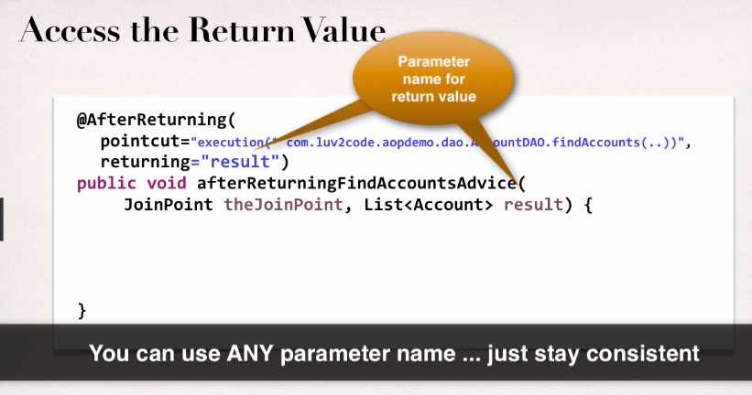

@AfterReturning(pointcut = "execution(* com.ucaru.AspectAdviceDemo.dao.AccountDAO.find*(..))", returning = "result")  
public void AfterReturningDaoAdvice(JoinPoint joinPoint, List<Account> result)  
{  
 //print signature  
 System.*out*.println("####### method signature: " + joinPoint.getSignature());  
 //modify results  
 if(!result.isEmpty())  
 {  
 for (Account acc : result)  
 {  
 String toUpper = acc.getName().toUpperCase();  
 acc.setName(toUpper);  
 }  
 }  
}

in this case it is known that this function will return a List<Account>, above method **is modifying return value of the function it adviced** only by changing the result variable without "return" statement because it has that dawg in it

one thing that should be taken account is that due to advices not actually apparent in the process flow teammates may be confused if they were not notified about

**lesson.375 @AfterThrowing**

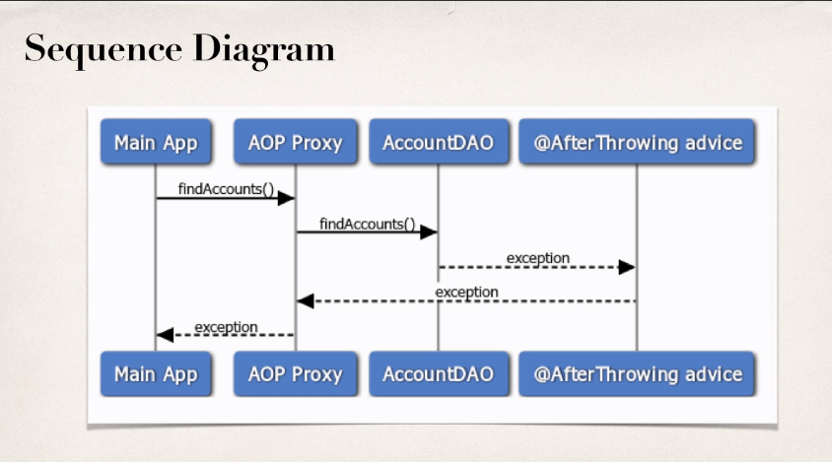

use cases:

logging, auditing, notification

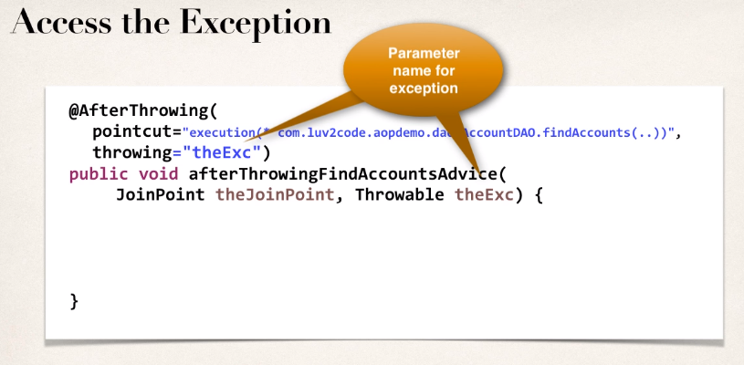

for @AfterThrowing it is not possible to intercept exception, it will still be propagated back to the main app, if interception is desired, @Around should be used

@Override  
public List<Account> findAccounts(boolean tripWire) {  
  
 //simulate an exception  
 if(tripWire)  
 {  
 throw new RuntimeException("FAKE EXCEPTION");  
 }

created a new method to simulate throwing an exception

try  
{  
 boolean tripWire = true;  
 accountList = dao.findAccounts(tripWire);  
} catch (Exception e) {  
 System.*out*.println("caught: " + e);  
}  
System.*out*.println("main");  
System.*out*.println(accountList);

in main application function call is encapsulated in a try-catch block

@AfterThrowing(pointcut = "execution(* com.ucaru.AspectAdviceDemo.dao.AccountDAO.find*(..))", throwing = "exc")  
public void afterThrowingDaoAdvice(JoinPoint joinPoint, Throwable exc)  
{  
 //print signature  
 System.*out*.println("####### method signature: " + joinPoint.getSignature().toShortString());  
 //log exception  
 System.*out*.println("####### exception: " + exc);  
  
}

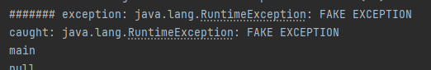

@AfterThrowing runs before try catch block

**lesson.378 @After**

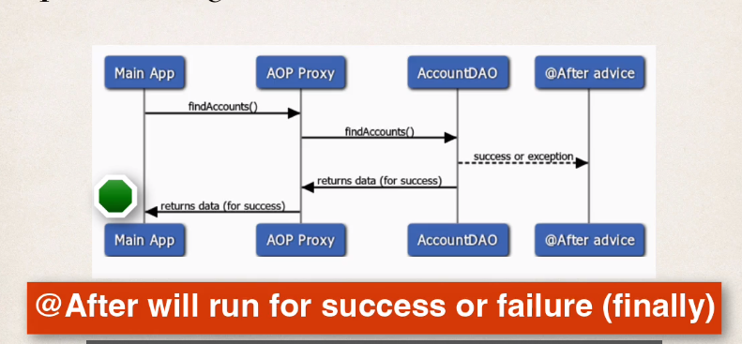

use cases:

log the exception, run regardless of the outcome, encapsulate functionality for further use

1.@After advice does not have access to the exception

if exception is needed, @AfterThrowing should be used

2. it should be run whether its success or error

code should not depend on happy path or exception

logging is the easiest case

@After("execution(* com.ucaru.AspectAdviceDemo.dao.AccountDAO.find*(..))")  
public void afterFinallyDaoAdvice(JoinPoint joinPoint)  
{  
 System.*out*.println("###after(finally)#### method signature: " + joinPoint.getSignature());  
}

**lesson.380 @Around**

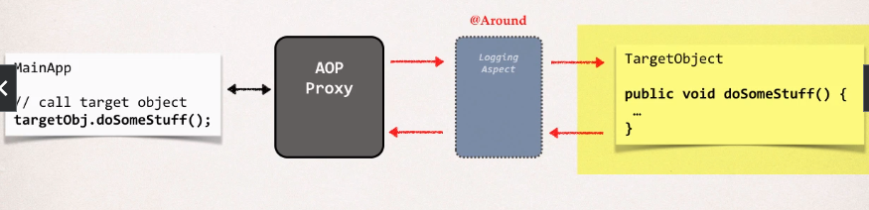

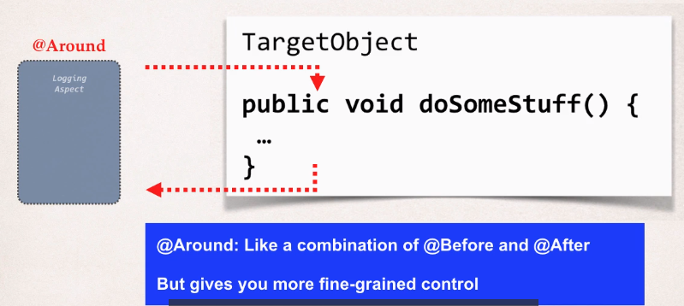

use cases: logging, auditing, security

pre-processing and post-processing

instrumentation, profiling :

how long does it take

for a section of code to run

manage exception

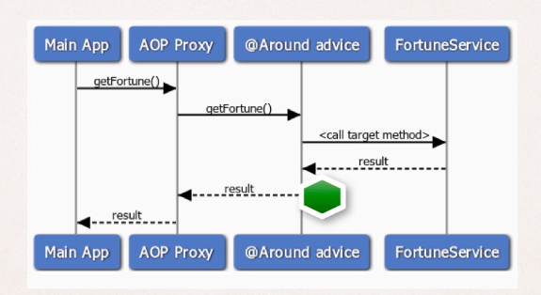

@Around can intercept before execution and after execution (like a combine of @Before and @After)

@Around("execution(* com.ucaru.AspectAdviceDemo.service.*.get*(..))")  
public Object aroundGetFortune(ProceedingJoinPoint proceedingJoinPoint) throws Throwable  
{  
 //print method  
 System.*out*.println("###around#### method signature: " + proceedingJoinPoint.getSignature());  
 //get timestamp  
 long begin = System.*currentTimeMillis*();  
 //execute  
 Object result = proceedingJoinPoint.proceed();  
 //get end-timestamp  
 System.*out*.println("object: " + result.getClass());  
 long end = System.*currentTimeMillis*();  
  
 //compute duration and print  
  
 long duration = end - begin;  
  
 System.*out*.println("#######around###### duration : " + duration/1000.0 + " #");  
  
 return result;  
}

runtime count example

for around, instead of JoinPoint ProceedingJoinPoint is used

throws Throwable (or wrap proceed method up in try catch block)

Object result = proceedingJoinPoint.proceed();

proceed allows adviced method to run an returns returned value of the adviced method as object (if method returns String then object is String value)

return result;

return value of around method overrides returned value of the adviced method

**lesson.384 @Around handle exception**

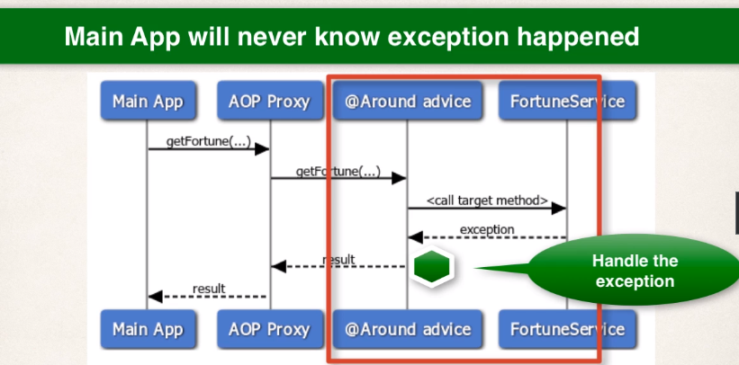

@Override  
public String getFortune(boolean tripWire) {  
 if(tripWire)  
 {  
 throw new RuntimeException("EXC");  
 }  
  
 return getFortune();  
}

create a new method that is set to throw a runtime exception

@Around("execution(* com.ucaru.AspectAdviceDemo.service.*.get*(..))")  
public Object aroundGetFortune(ProceedingJoinPoint proceedingJoinPoint) throws Throwable  
{  
 Object result = null;  
 //print method  
 System.*out*.println("###around#### method signature: " + proceedingJoinPoint.getSignature());  
 //get timestamp  
 long begin = System.*currentTimeMillis*();  
 //execute  
 try {  
 result = proceedingJoinPoint.proceed();  
 //get end-timestamp  
 System.*out*.println("object: " + result.getClass());  
 } catch (Exception e) {  
 System.*out*.println("######around##### exception handled: " + e.getMessage());  
 result = "problem on @Around";  
 }  
 long end = System.*currentTimeMillis*();  
 //compute duration and print  
  
 long duration = end - begin;  
 System.*out*.println("#######around###### duration : " + duration/1000.0 + " #");  
 return result;  
}

surround proceed() with try-catch

handle exception

main application will not know an exception is thrown because it is handled in @Around

**lesson.387 @Around re-throw exception**

try {  
 result = proceedingJoinPoint.proceed();  
 //get end-timestamp  
 System.*out*.println("object: " + result.getClass());  
} catch (Exception e) {  
 System.*out*.println("######around##### exception occurred: " + e.getMessage());  
 throw e;  
}

throw using "throw"

**lesson.388 spring mvc crud + aop**

@Aspect  
@Component  
public class DemoLoggingAspect {  
  
 // set up logger  
  
 private Logger logger = Logger.*getLogger*(getClass().getName());  
  
 @Pointcut("execution(* com.luv2code.springboot.thymeleafdemo.controller.*.*(..) )")  
 private void controllerPackage() {}  
  
 @Pointcut("execution(* com.luv2code.springboot.thymeleafdemo.service.*.*(..) )")  
 private void servicePackage() {}  
  
 @Pointcut("execution(* com.luv2code.springboot.thymeleafdemo.dao.*.*(..) )")  
 private void daoPackage() {}  
  
 @Pointcut("controllerPackage() || servicePackage() || daoPackage()")  
 private void anyPackage() {}  
  
 @Before("anyPackage()")  
 public void before(JoinPoint joinPoint)  
 {  
 //display called method  
 logger.info("###### before ###### "+ joinPoint.getSignature().toShortString() + " #");  
  
 //display arguments  
 Object[] args = joinPoint.getArgs();  
  
 for(Object arg : args)  
 {  
 logger.info("###### before ###### argument: " + arg + " #");  
 }  
  
 }  
  
 @AfterReturning(pointcut = "anyPackage()", returning = "result")  
 public void after(JoinPoint joinPoint, Object result)  
 {  
 //display returned method  
 logger.info("###### after ###### "+ joinPoint.getSignature().toShortString() + " #");  
  
 //display data returned  
 logger.info("###### after ###### result: "+ result+ " #");  
 }  
  
  
}

example of a personal logger program